Microsoft Business Intelligence and Information Management
Microsoft Business Intelligence and Information Management

Design Guidance
Prepared for
Customer Name
15-Apr-16
Version 1.0 Draft

Prepared by
Rod Colledge
Data Platform Solution Architect
rodcol@microsoft.com

Table of Contents
1 Introduction 7
1.1 How to read this Document 7
2 Microsoft Azure BI & IM Products and Services 8
2.1 Overview of IaaS, PaaS and SaaS 8
2.2 Summary of BI & IM Products and Services 10
3 Information Management Products and Services 11
3.1 SQL Server Data Quality Services 11
3.2 SQL Server Master Data Services 16
3.3 SQL Server Integration Services 18
3.4 Azure Data Factory 20
3.5 Azure Data Catalog 26
4 Data Storage Products and Services 33
4.1 SQL Server 33
4.2 Azure SQL Database 34
4.3 Azure SQL Data Warehouse 39
4.4 Azure Data Lake 44
4.5 Azure Blob Storage 49
4.6 DocumentDB, Redis Cache & Azure Table Storage 52
5 Analytics Products and Services 55
5.1 SQL Server Analysis Services 55
5.2 SQL Server Reporting Services 55
5.3 Power BI 57
5.4 Azure Machine Learning 61
5.5 Azure HDInsight 65
5.6 Azure Event Hub, Stream Analytics & IOT Suite 67
5.7 Cortana Intelligence Gallery 68
6 Example BI & IM Architecture 71
6.1 Background 71
6.2 Stage 1 73
6.3 Stage 2 75
6.4 Stage 3 77
Appendix A: Azure Service Availability (April 2016) 79

List of Figures
Figure 1: Separation of Responsibilities. IaaS vs. PaaS vs. SaaS 8
Figure 2: The Data Quality Process 12
Figure 3: Data Quality Knowledge Base Creation 13
Figure 4: Data Quality Domain Values specification 14
Figure 5: Data Quality Term-based Relations 14
Figure 6: Data Quality Cleansing as a component of an SSIS data transformation 15
Figure 7: SSIS Feature Pack for Azure 19
Figure 8: Azure Data Factory 20
Figure 9: Azure Data Factory Entities 21
Figure 10: SSIS Development with SQL Server Data Tools (SSDT) 22
Figure 11: Azure Data Factory development with JSON script 23
Figure 12: Data Factory Management Console in Azure Portal 23
Figure 13: Data Factory Data Source Support 24
Figure 14: Data Factory Pricing 25
Figure 15: Provisioning an Azure Data Factory 26
Figure 16: Azure Data Catalog Publisher tool 27
Figure 17: Publishing specific tables with Azure Data Catalog 28
Figure 18: Searching the Azure Data Catalog 29
Figure 19: Previewing Data in the Data Catalog 29
Figure 20: Adding Tribal Knowledge to data assets in Data Catalog 30
Figure 21: Data Profile information in Data Catalog 30
Figure 22: Provisioning an Azure Data Catalog 32
Figure 23: Azure Data Catalog Pricing 32
Figure 24: Azure SQL Database performance levels 35
Figure 25: Azure SQL Database service tiers 35
Figure 26: Azure SQL Database Elastic pool service tiers 36
Figure 27: Azure SQL Database Provisioning Process 37
Figure 28: Azure SQL Database Pricing 38
Figure 29: Azure SQL Data Warehouse Architecture 40
Figure 30: Provisioning Azure SQL DW 42
Figure 31: Azure SQL DW Pricing 43
Figure 32: Azure Data Lake Architecture 44
Figure 33: Azure Data Lake Store 45
Figure 34: Simple U-SQL Example 46
Figure 35: U-SQL Query using an intrinsic .NET method 46
Figure 36: U-SQL Query using a custom ..NET method 47
Figure 37: Data Lake Analytics 47
Figure 38: Provisioning Azure Data Lake 48
Figure 39: Azure Blob Storage Costs 50
Figure 40: Azure Blob Redundancy Options 51
Figure 41: Azure Premium Storage Costs 51
Figure 42: Provisioning an Azure Storage Account 52
Figure 43: Provisioning a DocumentDB database 54
Figure 44: SQL Server Business Intelligence Roadmap 57
Figure 45: Power BI Real-Time Traffic Dashboard 59
Figure 46: Power BI Architecture 59
Figure 47: Power BI Pricing Options 60
Figure 48: Azure Machine Learning Algorithms 61
Figure 49: Azure Machine Learning Development Interface 62
Figure 50: Azure Machine Learning Model Evaluation 62
Figure 51: Azure Machine Learning Templates 63
Figure 52: Azure Machine Learning Editions 63
Figure 53: Azure Machine Learning Pricing 64
Figure 54: Provisioning Azure Machine Learning 65
Figure 55: Apache Projects on HDInsight 65
Figure 56: Provisioning a HDInsight Cluster 66
Figure 57: HDInsight Cluster Configuration 67
Figure 58: Cortana Intelligence Solution Template 69

Revision and Signoff Sheet
Change Record
Date | Author | Version | Change reference
4 April 2016 | Rod Colledge | 0.1 | Initial draft
15 April 2016 | Rod Colledge | 1.0 | Updated with references

Reviewers
Name | Version approved | Position | Date

- Introduction
Microsoft are pleased to work with Customer Name on their Business Intelligence and Information Management (BI & IM) design, as part of their transition to the cloud.
This document will highlight the Microsoft BI & IM products and services available in Microsoft’s Azure Cloud. After highlighting the main differences between Azure Infrastructure as a Service (IaaS) and Platform as a Service (PaaS) offerings, focus will shift to the individual products and services within each, the configuration components they require, and the scenarios in which each product and service is best used. It will then walk through common scenarios in which the products and services are used together as part of a broader BI & IM solution architecture.
For completeness of vision, it will also cover Microsoft’s non-cloud products, and how these can be used as part of a hybrid BI & IM solution architecture.
Appendix A lists the current Azure service availability by region, allowing you to see which services are available in the Australian Data Centres.
  - How to read this Document
The intent is that this document will be referenced when designing the architecture of each workload Customer Name creates in (or migrates to) the cloud.
If you are not familiar with the many BI & IM products and services available from Microsoft, a great place to start is section 2, which provides a list of them, in the context of the delivery mechanism; Infrastructure, Platform or Software as a Service. Sections 3-5 then drills down into more detail, covering the best scenarios each product and service is used in, and the configuration components required to deploy them.
If you are already familiar with Microsoft’s BI & IM products and services, but wish to see how they work together, Section 6 provides an example of an end-to-end BI & IM architecture, and can be used as a quick-start template for Customer Name applications.

- Microsoft Azure BI & IM Products and Services
  - Overview of IaaS, PaaS and SaaS
One of the core decisions when designing any modern cloud-based solution is the delivery method, with the three core methods being Infrastructure as a Service (IaaS), Platform as a Service (PaaS) and Software as a Service (SaaS).
SaaS solutions are those where you simply purchase the service without needing to plan or budget for hardware or platform maintenance. Great examples are Office 365, Power BI and Salesforce.com.
PaaS solutions are those where you provide your own data and/or application, and the rest of the solution is maintained for you. PaaS solutions remove the need to maintain the operating system and the platform on which the data and/or application is hosted. Azure SQL Database is a great example of a PaaS service, removing the need to install, configure and maintain a traditional Database Management System, such as SQL Server.
IaaS solutions are those that allow you to purchase space to manage your own infrastructure, but unlike traditional on-premises solutions, you don’t need to physically build or install the underlying hardware.
A great way of looking at the differences between these three models is by considering the responsibilities of each approach, as shown in figure 1.
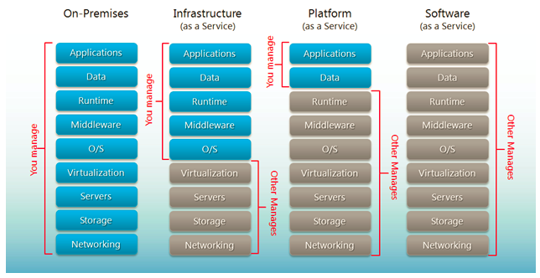
Figure 1: Separation of Responsibilities. IaaS vs. PaaS vs. SaaS

As organisations move from legacy on-premises implementations to the cloud, they typically start by provisioning new virtual machines as IaaS services, or by migrating on-prem virtual machines to the cloud as IaaS virtual machines, commonly referred to as a “lift and shift” approach. While this approach offers increased agility in provisioning new environments, and a financial move from a Capex to Opex model, it doesn’t fully embrace the opportunities of cloud computing.
IaaS implementations are best suited to initial cloud deployments, or where a high level of control is required over the underlying infrastructure.
In contrast to IaaS, SaaS solutions are those that require zero administration, and are best suited to well-defined application scenarios.
A great balance between IaaS and SaaS, is PaaS, where the underlying infrastructure is fully managed, with the ability to bring your own data and applications to the platform. A great example of this is building a cloud-hosted application that takes advantage of the underlying platform features such as elastic-scale and geo-redundancy, that uses Azure SQL Database as a data store, eliminating all, or most, of the need for SQL Server database administration expertise.
The next section lists the Microsoft BI & IM products and services by function, specifying the delivery method (IaaS, PaaS, or SaaS). In the sections that follow, we’ll cover each product and service in more depth, and the best use-case scenario(s) for each.

  - Summary of BI & IM Products and Services
Product | Data Governance | Data Orchestration | Data Storage | Semantic Modelling | Reporting / Analytics | Predictive Analytics | Streaming Analytics
Data Quality Services | IAAS
Master Data Services | IAAS
Integration Services |  | IAAS
Data Factory |  | PAAS
Data Catalog | PAAS
SQL Server |  |  | IAAS |  |  | IAAS
SQL Database |  |  | PAAS
Data Lake |  |  | PAAS |  | PAAS
Blob Storage |  |  | PAAS
Document DB |  |  | PAAS
Redis Cache |  |  | PAAS
Azure Table Storage |  |  | PAAS
Analysis Services |  |  |  | IAAS |  | IAAS
Reporting Services |  |  |  |  | IAAS
Power BI |  |  |  | SAAS | SAAS
Azure Machine Learning |  |  |  |  |  | PAAS
HDInsight |  |  | PAAS |  | PAAS | PAAS
Event Hubs |  |  |  |  |  |  | PAAS
Stream Analytics |  |  |  |  |  |  | PAAS
IOT Hubs |  |  |  |  |  |  | PAAS
Notification Hubs |  |  |  |  |  |  | PAAS

- Information Management Products and Services
  - SQL Server Data Quality Services
    - Overview
Incorrect data can result from user entry errors, corruption in transmission or storage, mismatched data dictionary definitions, and other data quality and process issues. Aggregating data from different sources that use different data standards can result in inconsistent data, as can applying an arbitrary rule or overwriting historical data. Incorrect data affects the ability of a business to perform its business functions and to provide services to its customers, resulting in a loss of credibility and revenue, customer dissatisfaction, and compliance issues. Automated systems often do not work with incorrect data, and bad data wastes the time and energy of people performing manual processes. Incorrect data can wreak havoc with data analysis, reporting, data mining, and warehousing.
Data Quality Services provides the following features to resolve data quality issues;
Data Cleansing; the modification, removal, or enrichment of data that is incorrect or incomplete, using both computer-assisted and interactive processes
Matching; the identification of semantic duplicates in a rules-based process that enables you to determine what constitutes a match and perform de-duplication
Reference Data Services; verification of the quality of your data using the services of a reference data provider. You can use reference data services from Windows Azure Marketplace Data Market to easily cleanse, validate, match, and enrich data
Profiling; the analysis of a data source to provide insight into the quality of the data at every stage in the knowledge discovery, domain management, matching, and data cleansing processes. Profiling is a powerful tool in a DQS data quality solution. You can create a data quality solution in which profiling is just as important as knowledge management, matching, or data cleansing
Monitoring; the tracking and determination of the state of data quality activities. Monitoring enables you to verify that your data quality solution is doing what it was designed to do
Knowledge Base; Data Quality Services is a knowledge-driven solution that analyses data based upon knowledge that you build with DQS. This enables you to create data quality processes that continually enhances the knowledge about your data and in so doing, continually improves the quality of your data

Figure 2 shows the various stages of the data quality process working together as part of an Enterprise Information Management (EIM) process. Essentially, the steps are to profile the data to discover quality issues, create data policies, cleanse and de-duplicate the data, automate the cleansing, and optionally, store a subset of the cleansed data as Master Data.
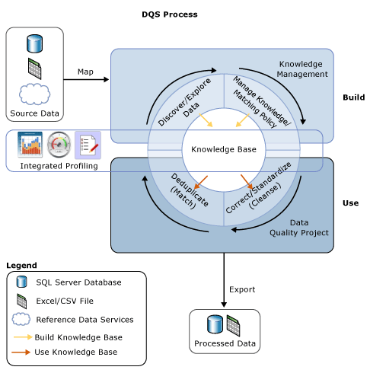
Figure 2: The Data Quality Process

SQL Server Data Quality Services provides rich tooling to profile and cleanse data. Figure 3 shows the Data Quality Tool being used to create an Employee Knowledge Base, with a rule for email address needing to conform to a specific pattern.

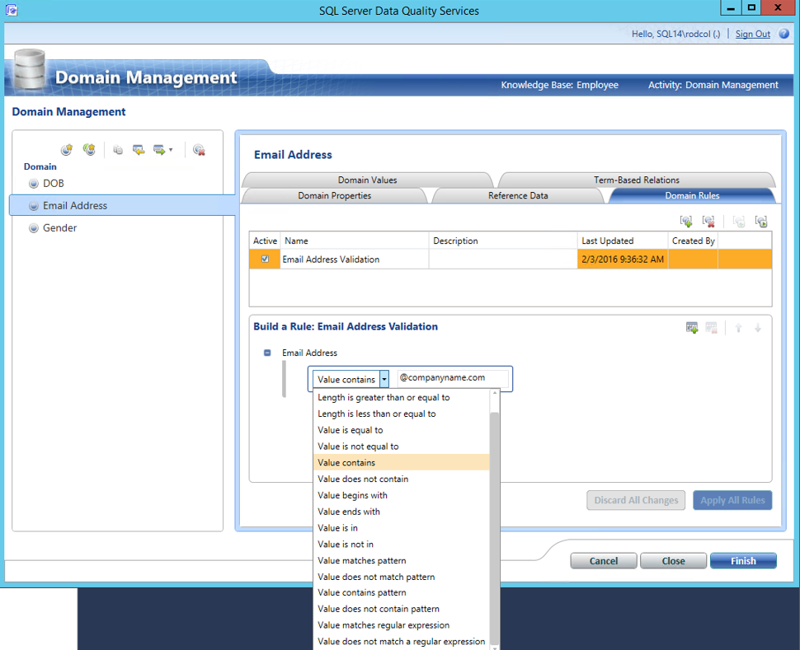
Figure 3: Data Quality Knowledge Base Creation
Beyond basic domain rules, the Data Quality tools allow you to specify domain value substitutions and term-based relations, as shown in figures 4 and 5.
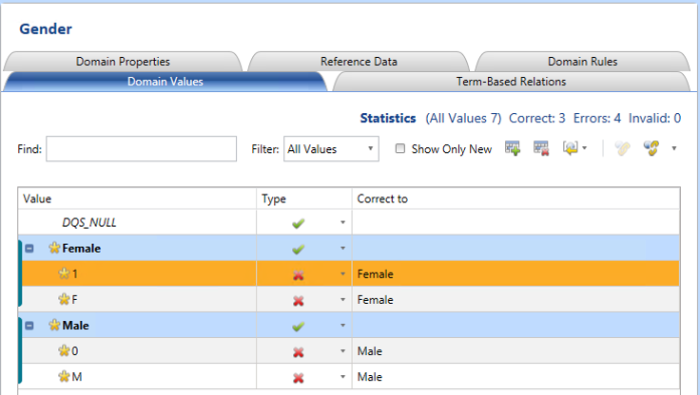
Figure 4: Data Quality Domain Values specification

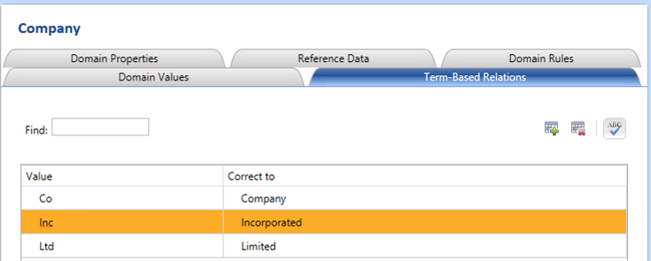
Figure 5: Data Quality Term-based Relations

Once created, the Data Quality rules can be run interactively using the DQS tools, or automatically using SQL Server Integration Services components. Figure 6 shows an SSIS pipeline that uses the DQS Cleansing component as part of a data load pipeline.
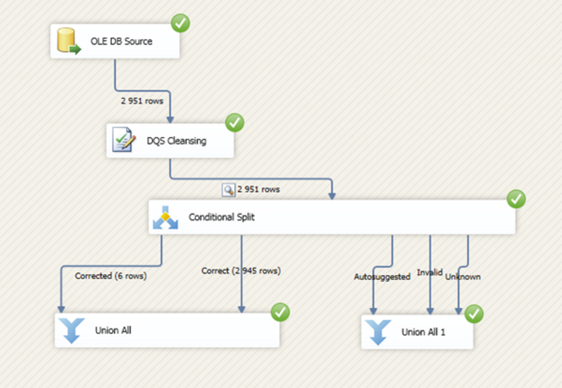
Figure 6: Data Quality Cleansing as a component of an SSIS data transformation
References;
- https://technet.microsoft.com/en-us/library/ff877917(v=sql.110).aspx
    - Best Use-Case Scenario
SQL Server Data Quality Services is best used in any situation where poor data quality will have a measurable negative impact on business performance. It is often used as a component of an Enterprise Data Warehouse load, but can also be deployed for point solutions for data marts and line of business applications.
    - Required Components
Data Quality Services is included as a component of the Enterprise Edition of SQL Server. There is no Azure hosted PaaS implementation of Data Quality Services, meaning it’s provisioned as an IaaS SQL Server Virtual Machine, or an On-Premises implementation.
  - SQL Server Master Data Services
    - Overview
Master Data Services (MDS) is the SQL Server solution for Master Data Management (MDM), which enables your organization to discover and define non-transactional lists of data, and compile maintainable, reliable master lists.
In the context of an MDM solution, master data are the data sets at the centre of business activities, such as Customers, Products, Cost Centres, Locations, Assets and Tasks. They are the dimensions (things) in a Data Warehouse, not the facts (events).
MDM projects are often born out of situations in which multiple heterogeneous systems contain the same things (dimensions), but are maintained separately, and are often in conflict with each other, leading to multiple versions of the truth.
When loading data from these heterogeneous systems into a consolidated data warehouse for enterprise reporting, conflicting data sets often lead to poor outcomes in analytics accuracy, with IT staff spending considerable time “fixing” conflicting data, however, they typically lack the business expertise to identify the correct value.
SQL Server Master Data Services puts tools in the hands of expert business users to define and compile maintainable, reliable, master lists, with the ability to disseminate this high quality master data to subscribing systems downstream, ensuring a single source of truth for both heterogeneous systems, and enterprise data warehouses and data marts.
There are several different types of MDM Architectures;
Repository; In the Repository approach, the complete collection of master data for an enterprise is stored in a single database. The repository data model must include all the attributes required by all the applications that use the master data. The applications that consume, create, or maintain master data are all modified to use the master data in the hub, instead of the master data previously maintained in the application database. For example, the Order Entry and CRM applications would be modified to use the same set of customer tables in the master-data hub, instead of their own data stores.
While the advantages of this approach are clear, it’s rarely practical, given the changes required to each source system. These changes are likely to be very expensive, and for some applications, simply not possible.
Registry; In the Registry approach, none of the master-data records is stored in the MDM hub. The master data is maintained in the application databases, and the MDM hub contains lists of keys that can be used to find all the related records for a particular master-data item. For example, if there are records for a particular customer in the CRM, Order Entry, and Customer Service databases, the MDM hub would contain a mapping of the keys for these three records to a common key.
Because each application maintains its own data, the changes to application code to implement this model are usually minimal, and current application users generally do not need to be aware of the MDM system.
The downside of this model is that every query against MDM data is a distributed query across all the entries for the desired data in all the application databases. If the query is going against a particular customer, this is probably not an unreasonable query. But if you want a list of all customers who have ordered a particular product in the last six months, you may need to do a distributed join across tables from 5 or even 10 databases. Doing this kind of large, distributed query efficiently is pretty difficult.
Hybrid; As the name implies, the hybrid model includes features of both the repository and registry models. It recognizes that, in most cases, it is not practical (in the short term, at least) to modify all applications to use a single version of the master data, and also that making every MDM hub query a distributed query is very complex and probably will not provide acceptable performance. The hybrid model leaves the master-data records in the application databases and maintains keys in the MDM hub, as the registry model does. But it also replicates the most important attributes for each master entity in the MDM hub, so that a significant number of MDM queries can be satisfied directly from the hub database, and only queries that reference less-common attributes have to reference the application database.

The Hybrid solution is a “best of both worlds” approach, but given the actual data is replicated centrally, there has to be a way of dealing with conflicting data. SQL Server Master Data Services provides tools for exactly that purpose.
MDS includes the following components and tools;
- Master Data Services Configuration Manager, a tool you use to create and configure Master Data Services databases and web applications
- Master Data Manager, a web application you use to perform administrative tasks, such as creating a domain model or business rules, updating data
- Master Data Services Add-in for Excel, With the SQL Server Master Data Services Add-in for Excel, you can load filtered lists of data from MDS into Excel, where you can work with it just as you would any other data. When you are done, you can publish the data back to MDS, where it is centrally stored. Security determines which data you can view and update.
- Master Data Services Subscription Views; To integrate master data into both operational and analytical systems, you can export Master Data Services data to subscribing systems by creating subscriptions views. Any subscribing system can then view and consume the published data in the Master Data Services database
Finally, Master Data Services can be programmatically extended through the included APIs and stored procedures. A great example of that is the Master Data Maestro Suite tool from Profisee, a Microsoft Gold Application Development Partner. The Master Data Maestro Suite delivers advanced MDM capabilities at the enterprise level to organizations deploying the Microsoft SQL Server Master Data Services (MDS) platform.
References;
- https://msdn.microsoft.com/en-us/library/ee633763.aspx
    - Best Use-Case Scenario
SQL Server Master Data Services is best used in any situation where there are multiple, often conflicting, sources of truth for important reference sets such as customers and products. It’s often used in Merger and Acquisition scenarios, and in large enterprises with multiple systems and overlapping data sets.
    - Required Components
Like Data Quality Services, Master Data Services is included as a component of the Enterprise Edition of SQL Server. There is no Azure hosted PaaS implementation of Master Data Services, meaning it’s provisioned as an IaaS SQL Server Virtual Machine, or an On-Premises implementation.
  - SQL Server Integration Services
    - Overview
Microsoft Integration Services is a platform for building enterprise-level data integration and data transformations solutions. You use Integration Services to solve complex business problems by copying or downloading files, sending e-mail messages in response to events, updating data warehouses, cleaning and mining data, and managing SQL Server objects and data. The packages can work alone or in concert with other packages to address complex business needs. Integration Services can extract and transform data from a wide variety of sources such as XML data files, flat files, and relational data sources, and then load the data into one or more destinations.
Integration Services includes a rich set of built-in tasks and transformations, tools for constructing packages, and the Integration Services service for running and managing packages. You can use the graphical Integration Services tools to create solutions without writing a single line of code, or you can program the extensive Integration Services object model to create packages programmatically and code custom tasks and other package objects.
Earlier, figure 3 showed how can use an SSIS package to call a previously defined Data Quality Cleansing rule as part of a data transformation. One of the great things about SSIS is the integration with the broader Microsoft ecosystem. A good example of that is shown in figure 7, which uses components from the SSIS Feature Pack for Azure to spin up a HDInsight Cluster, ingest data stored in an Azure Blob, and run some Hive scripts before turning off the cluster to reduce costs.

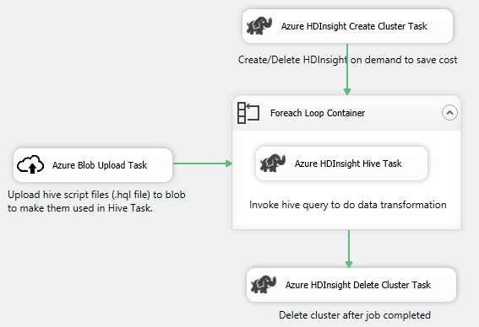
Figure 7: SSIS Feature Pack for Azure
References;
- https://msdn.microsoft.com/en-us/library/ms141026.aspx
    - Best Use-Case Scenario
SSIS is the de-facto standard for Microsoft developers to perform data extraction, transformation and loading to destination systems. It has a mature development environment, an extensive collection of data transformation patterns, and native support for almost every data platform.
    - Required Components
SQL Server Integration Services is included as a component of SQL Server, but unlike DQS and MDS, SSIS is available in the standard edition of SQL Server, although some advanced features are only available in the enterprise edition.
There is no direct equivalent of SSIS available as an Azure hosted PaaS service, meaning it’s provisioned as an IaaS SQL Server Virtual Machine, or an On-Premises implementation. In the next section, we’ll cover Azure Data Factory, which can be used to perform similar ETL tasks to SSIS, although there are some important distinctions between the two tools which will be highlighted.
  - Azure Data Factory
    - Overview
Azure Data Factory, shown in figure 8, is a cloud-based data integration service that orchestrates and automates the movement and transformation of both cloud-based and on-premises data sources. It includes feature-rich monitoring and management tools to visualise the current state of your data pipelines, including data lineage and pipeline dependencies.
Azure Data Factory itself does not store any data. It lets you create data-driven flows to orchestrate movement of data between supported data stores and processing of data using compute services in other regions or in an on-premises environment. It also allows you to monitor and manage workflows using both programmatic and UI mechanisms.
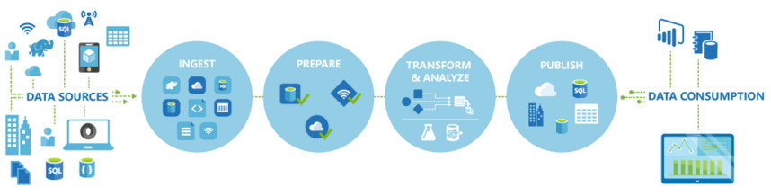
Figure 8: Azure Data Factory
As at April 2016, Azure Data Factory is only available in the West US and North Europe regions, however, the services powering the data movement in Data Factory are available globally in several regions. For data stored on-premises behind a firewall, the Microsoft Data Management Gateway is installed in your on-premises environment and is used by Data Factory to access the data.
As an example, let’s assume that your compute environments such as an Azure HDInsight cluster and Azure Machine Learning are running out of West Europe region. You can create and leverage an Azure Data Factory instance in North Europe and use it to schedule jobs on your compute environments in West Europe. It takes a few milliseconds for the Data Factory service to trigger the job on your compute environment but the time for executing the job on your compute environment does not change.
As per figure 9, Azure Data Factory has a few key entities that work together to define the input and output data, processing events, and the schedule and resources required to execute the desired data flow.
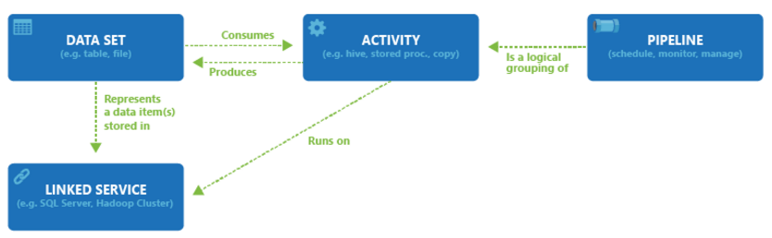
Figure 9: Azure Data Factory Entities

Activities define the actions to perform on your data. Each activity takes zero or more datasets as inputs and produces one or more datasets as outputs. An activity is a unit of orchestration in Azure Data Factory. For example, you may use a Copy activity to orchestrate copying data from one dataset to another. Similarly, you may use a Hive activity which will run a Hive query on an Azure HDInsight cluster to transform or analyze your data. Azure Data Factory provides a wide range of data transformation, analysis, and data movement activities.
Pipelines are a logical grouping of Activities. They are used to group activities into a unit that together perform a task. For example, a sequence of several transformation Activities might be needed to cleanse log file data. This sequence could have a complex schedule and dependencies that need to be orchestrated and automated. All of these activities could be grouped into a single Pipeline named “CleanLogFiles”. “CleanLogFiles” could then be deployed, scheduled, or deleted as one single unit instead of managing each individual activity independently.
Datasets are named references/pointers to the data you want to use as an input or an output of an Activity. Datasets identify data structures within different data stores including tables, files, folders, and documents.
Linked services define the information needed for Data Factory to connect to external resources. Linked services are used for two purposes in Data Factory;
- To represent a data store including, but not limited to, an on-premises SQL Server, Oracle DB, File share or an Azure Blob Storage account. As discussed above, Datasets represent the structures within the data stores connected to Data Factory through a Linked service
- To represent a compute resource that can host the execution of an Activity. For example, the “HDInsight Hive Activity” executes on an HDInsight Hadoop cluster
    - SSIS vs. Azure Data Factory
Both Azure Data Factory and SSIS are used to orchestrate the movement and transformation of data between source and destination, but there are a few key differences between the tools.
Development Tools; SSIS development is done through the mature SQL Server Data Tools (SSDT) product and includes pre-built transformations for common tasks such as lookups, conditional splits and unions, and more advanced tasks such as fuzzy lookups. In contrast, Azure Data Factory takes more of a script-centric approach using JSON, Hive, Pig and C#.

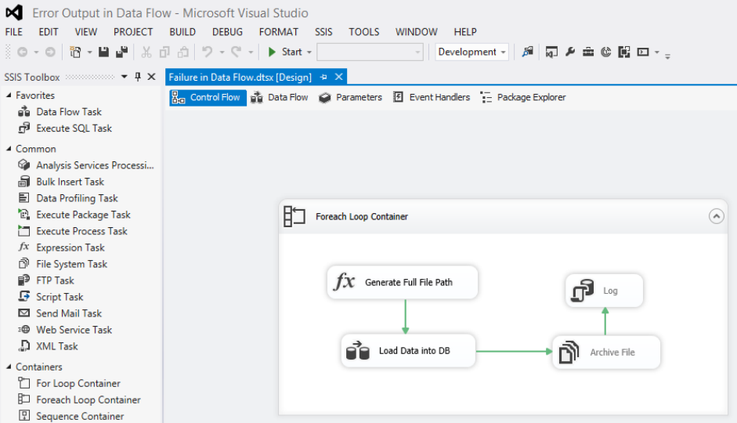
Figure 10: SSIS Development with SQL Server Data Tools (SSDT)

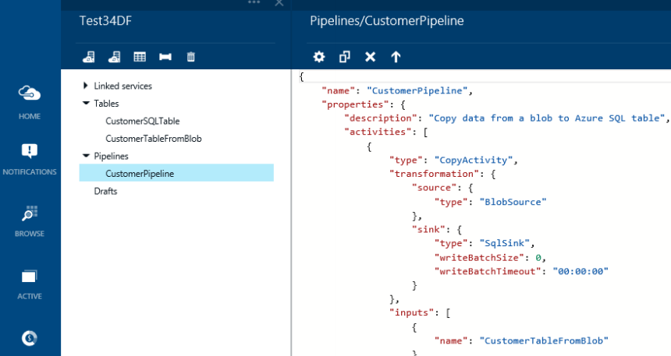
Figure 11: Azure Data Factory development with JSON script

Administration; SSIS packages are managed and monitored through SQL Server tools such as Management Studio, SSIS Catalog Reports and SSIS logging, whereas Data Factory pipelines are managed in the Azure Portal, or via Powershell cmdlets. Data Factory also includes a very strong Data Lineage feature, something lacking in SSIS.
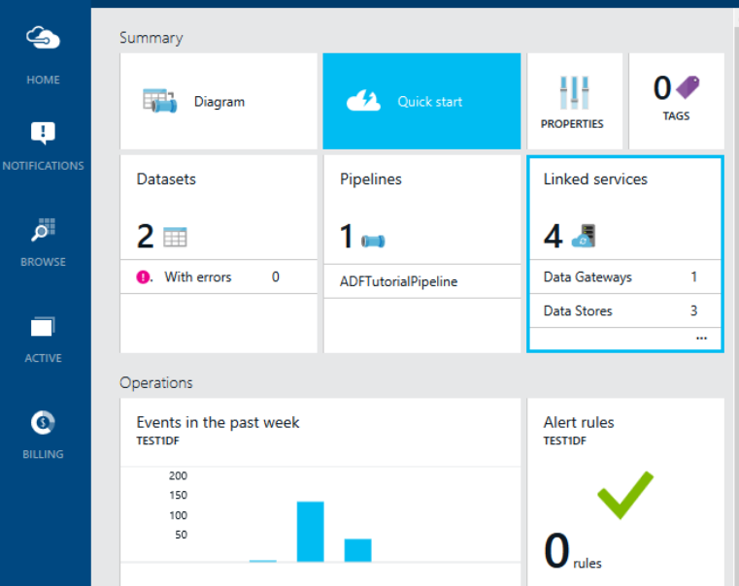
Figure 12: Data Factory Management Console in Azure Portal
Data Source Support; SSIS supports a wide range of data source and destinations, including SQL Server Oracle, SAP, Access, Teradata, Web Services, Azure SQL DW & DB and via the Azure Feature Pack, Azure Blobs and HDInisght. In contrast, the supported source and destinations for Data Factory are not as broad, although this will improve over time. Figure 13 lists the current sources and sinks (destinations) supported by Azure Data Factory. Note that for on-premises data, the Microsoft Data Management Gateway is required for data connectivity.
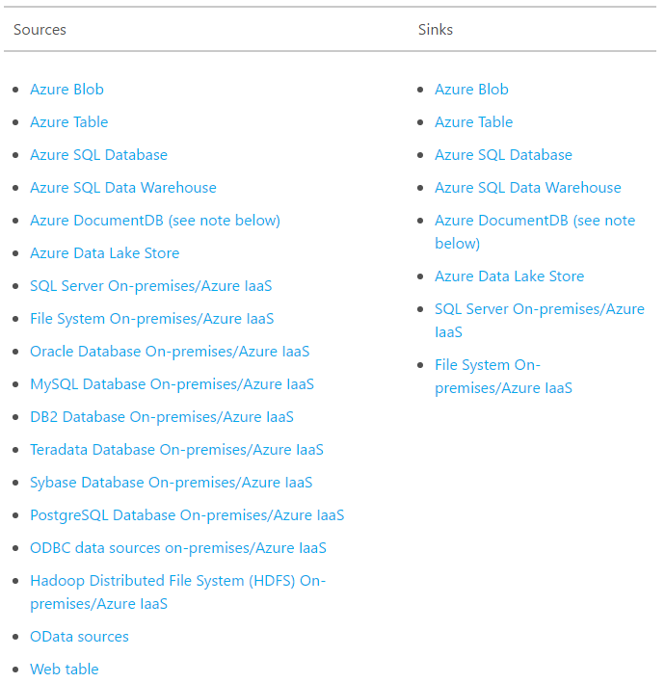
Figure 13: Data Factory Data Source Support

Environment and Licensing; SSIS is an included component in the SQL Server license, and requires that you provision and manage the underlying hardware on which the packages run. In contrast, Azure Data Factory is a pay-per-use cloud hosted service that requires zero hardware maintenance, and can easily scale beyond what was originally anticipated.
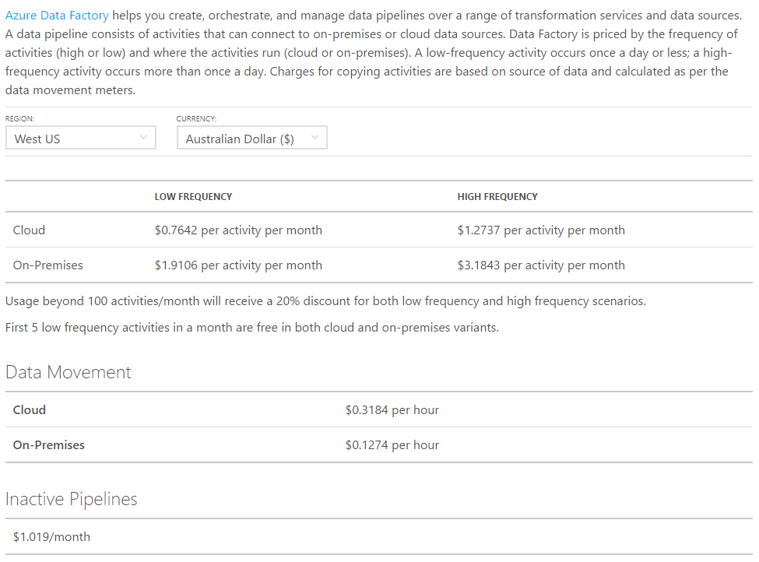
Figure 14: Data Factory Pricing
References;
- https://azure.microsoft.com/en-us/documentation/articles/data-factory-introduction/
    - Best Use-Case Scenario
The major benefit of Data Factory over SSIS is that you are using the dynamic scale features of the cloud, and you only pay for what you use. In situations where the data load fluctuates, and is difficult to anticipate, Data Factory provides a flexible, cost effective alternative to building your own SSIS environment. On the downside, it requires a good grasp of scripting languages such as JSON, Hive and Pig. As such, it’s better suited to application developers than Business Intelligence developers, who can take advantage of pre-built transformations in the mature GUI environment of SSIS development.

    - Required Components
Data Factory can be easily provisioned in your Azure Subscription via the Portal. During creation, the portal will ask which Resource Group to provision the Factory in. No other information is required to create the Factory.
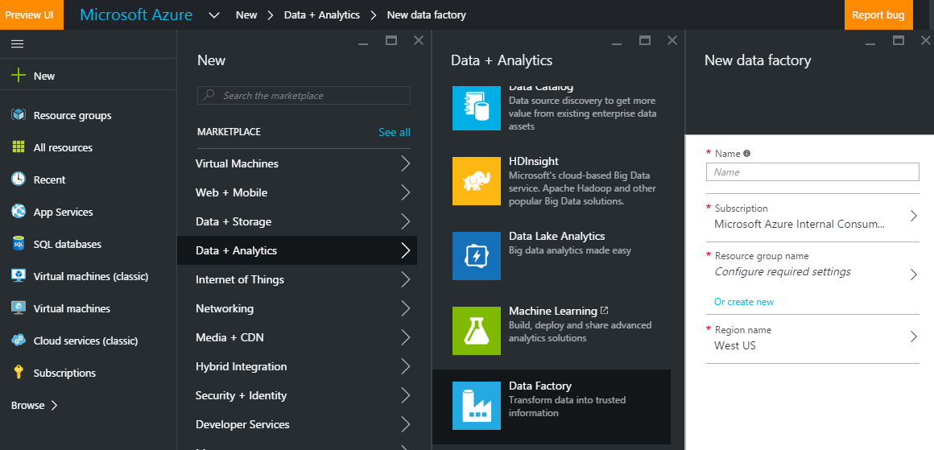
Figure 15: Provisioning an Azure Data Factory
  - Azure Data Catalog
    - Overview
In a typical enterprise environment in which a single source of all enterprise data does not exist, business users often struggle to find the data they need for analysis and decision making. Worse, they might be using an old copy of data, a test system, or data that was never intended for decision making.
As part of a broader data governance process, Data Catalog allows Data Stewards to publish the meta-data of the high value business data assets to a single catalog, from which business users can search for the data they need, and open it in a tool of their choice.
In effect, Azure Data Catalog places a logical layer over the top of the underlying complex data landscape and acts as a redirector service to connect users with the correct data to use. Data Catalog also supports the concept of “Tribal Knowledge”, allowing both data stewards and business users to add tags, synonyms and documentation to the data assets, increasing the likelihood of business users finding the data they need using terms they are familiar with.
Azure Data Catalog using a simple Publish and Discover approach. A Data Steward publishes selected meta-data from one or more sources to an organisation’s catalog, and then users discover the meta-data using search terms, before optionally connecting to the data for self-service reporting in a tool such as Power BI.
A data steward uses the Data Catalog Publisher tool to select one or more data sources to publish. As shown in Figure 16, the first step is selecting the source to publish from.
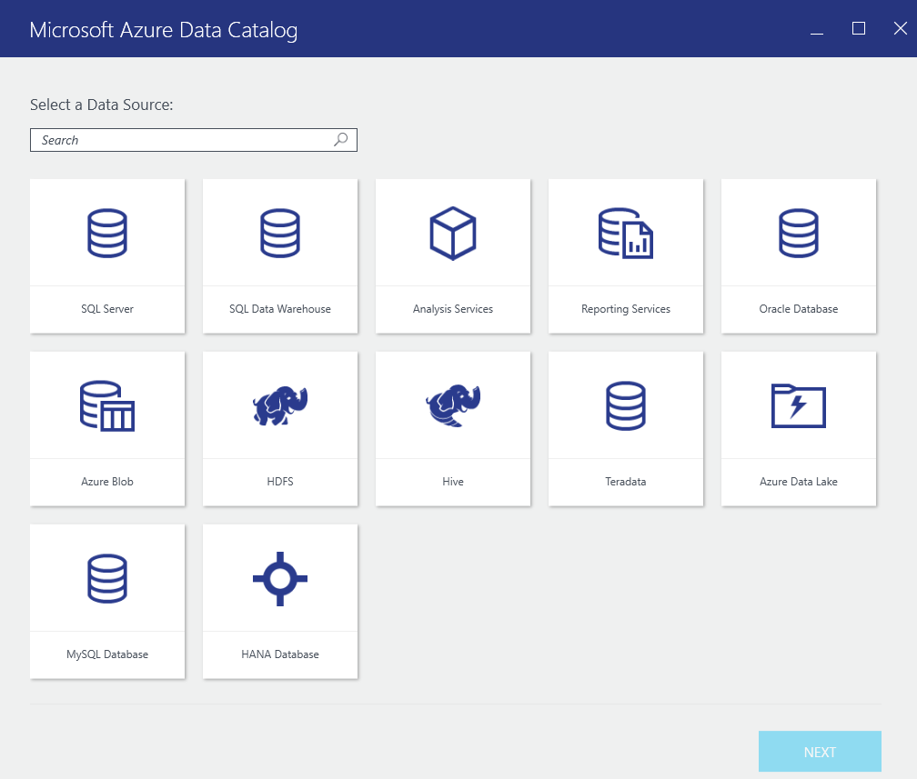
Figure 16: Azure Data Catalog Publisher tool
Once the source is selected, the steward can choose one or more specific data items (tables, views etc) to publish the meta-data from. As shown in figure 17, the steward can choose to include sample data in the publish, as well as specifying an expert for the data. This could be a business user with deep knowledge about the data, central help desk, or any other contact associated with the data.
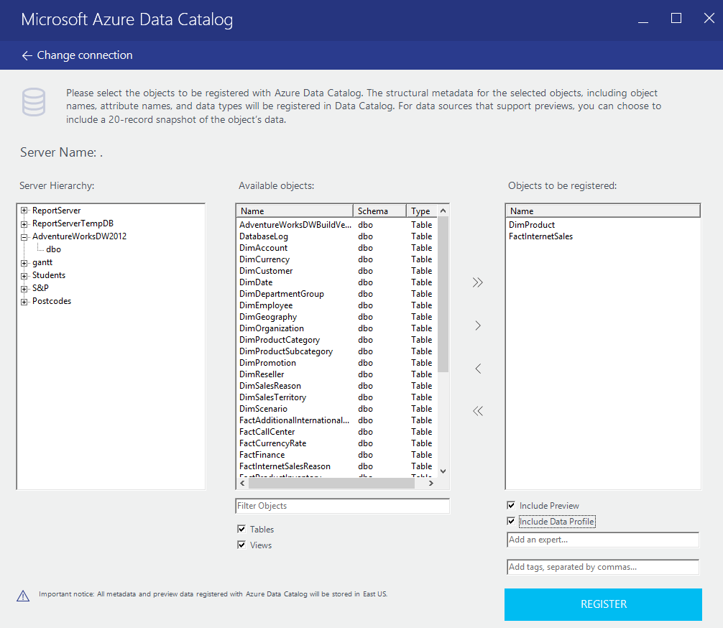
Figure 17: Publishing specific tables with Azure Data Catalog
Once the steward has published the selected meta data, business users are free to browse the data. As shown in figure 18, a business user has searched on “Quota” with various results returned from the catalog. On the right hand side, the user can opt to see additional information such as previewing the data (if a preview was uploaded), column level detail, a profile of the data, and any documentation on the data set.
Figures 19 shows the preview mode, allowing the business user to get a feel for the data. Note that the data catalog does not store the data itself, just the meta-data. In this case, a small sample of data was selected during the publish process.

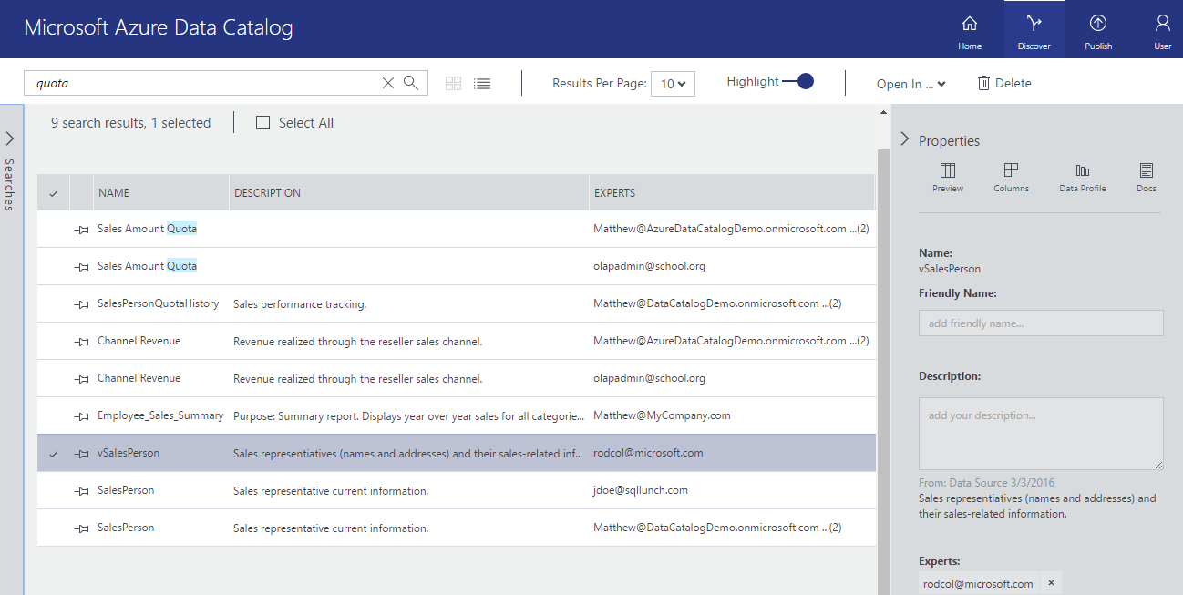
Figure 18: Searching the Azure Data Catalog
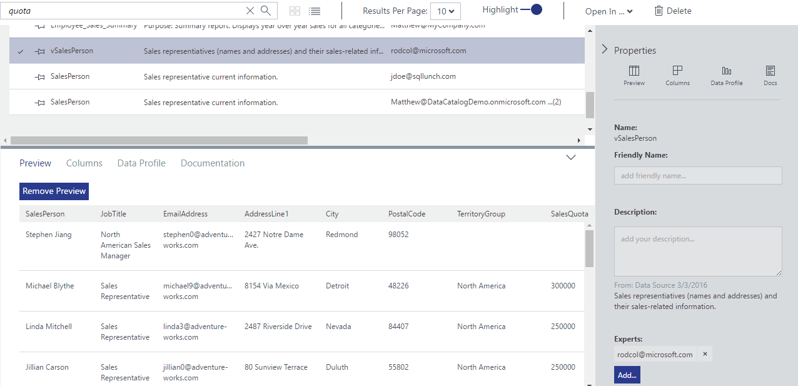
Figure 19: Previewing Data in the Data Catalog
As shown in figure 20, selecting the column view on the right hand side allows the business user to see the columns contained with the data. This also allows them to add tags to the description for each column, which builds the “tribal knowledge”, assisting other business users to find data within the catalog.
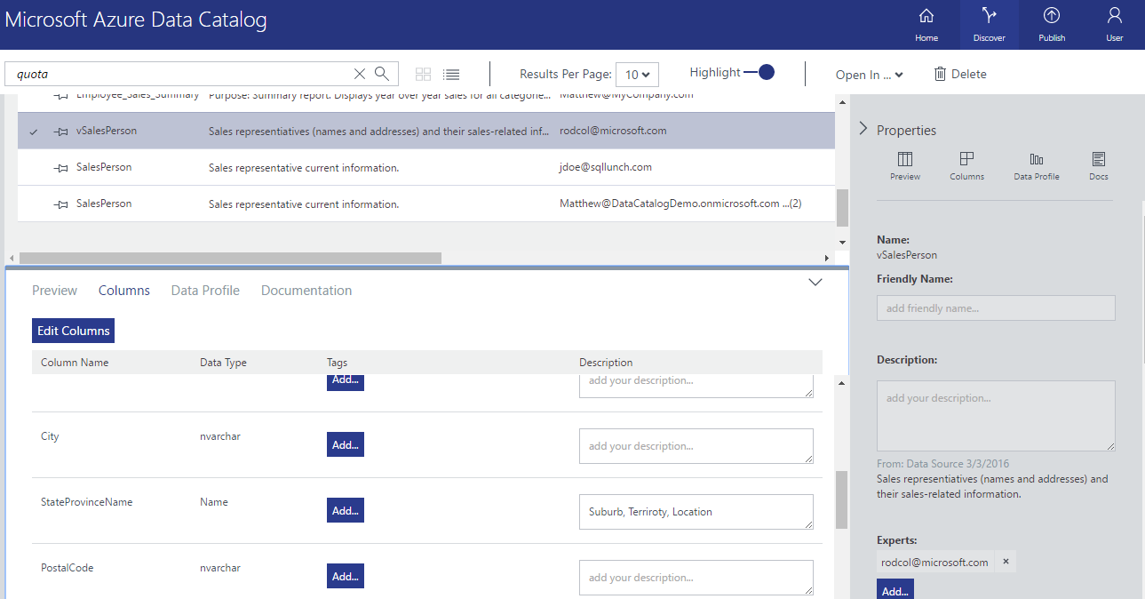
Figure 20: Adding Tribal Knowledge to data assets in Data Catalog
As show in figure 21, the data profile view provides information on the distribution of data within the data catalog.
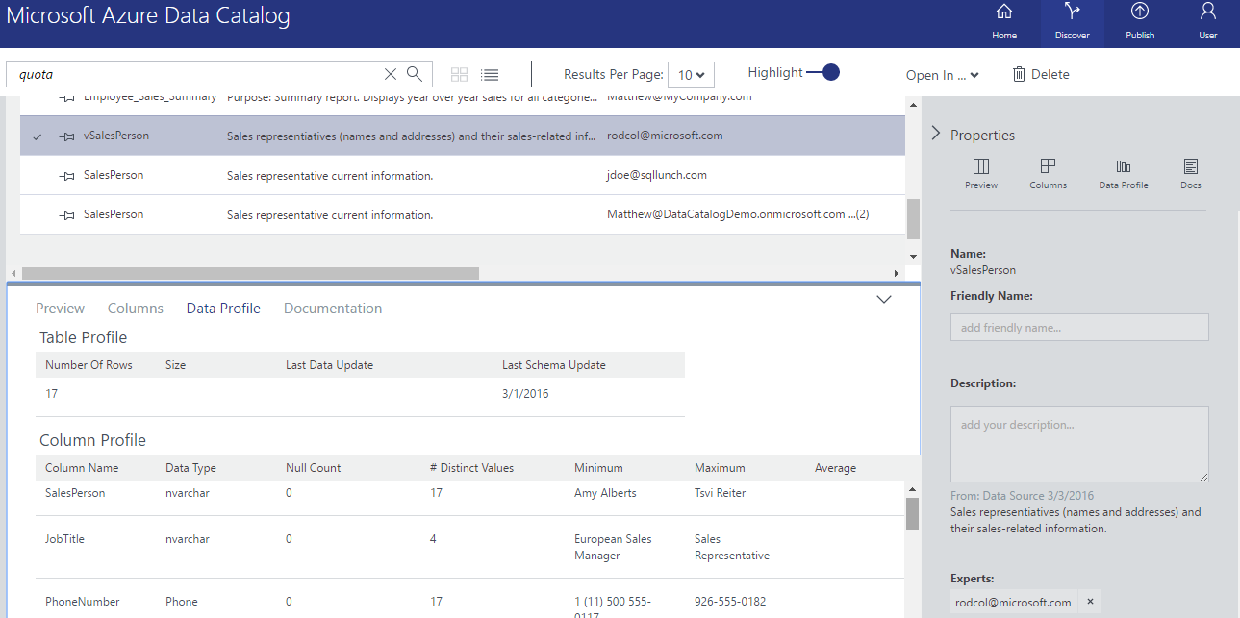
Figure 21: Data Profile information in Data Catalog
Finally, a data steward can select the Docs view to enter information of relevance for the business user to read during their discovery process.
Once the business user has decided that they have found the data they are looking for, they can use the “Open In …” link at the top of the discovery window to open the data in the tool of their choice, currently Excel, Power BI or SQL Server Data Tools. If a user selects Excel, a “.odc” file will download, and when opened, will launch Excel with a connection to the data source. If Power BI is selected, a “.pbix” file will download, and Power BI will open with a connection to the data source. In all cases, the business user requires permissions to the data source; if they don’t have access, they will receive a permission denied error, however, using the information in the catalog, they know who to contact to request access.
References;
- https://azure.microsoft.com/en-us/pricing/details/data-catalog/
    - Best Use-Case Scenario
Azure Data Catalog is a unique tool that’s perfect for bringing clarity to complex data environments. Its clear strength is being able to publish selected meta-data from a broad collection of different data types to a single point for ease of discovery and consumption, avoiding the lengthy and expensive process to physically integrate all data together. The tribal knowledge, preview mode and documentation features enhance the discovery process, and the “Open In” feature connects Self-Service Discovery to Self-Service Reporting.
Microsoft have made a series of APIs available to open up the integration possibilities of Azure Data Catalog. The obvious win for this is making the Catalog searchable from inside applications such as Power BI.
    - Required Components
As per figure 22, Azure Data Catalog can be easily provisioned in your Azure Subscription via the Portal. During creation, the portal will ask which Resource Group to provision the Catalog in. No other information is required to create the Factory.
Azure Data Catalog is free for up to 5000 catalog objects. Beyond that, it’s charged per user. Figure 23 lists the current retail pricing for Azure Data Catalog, as at April 2016.

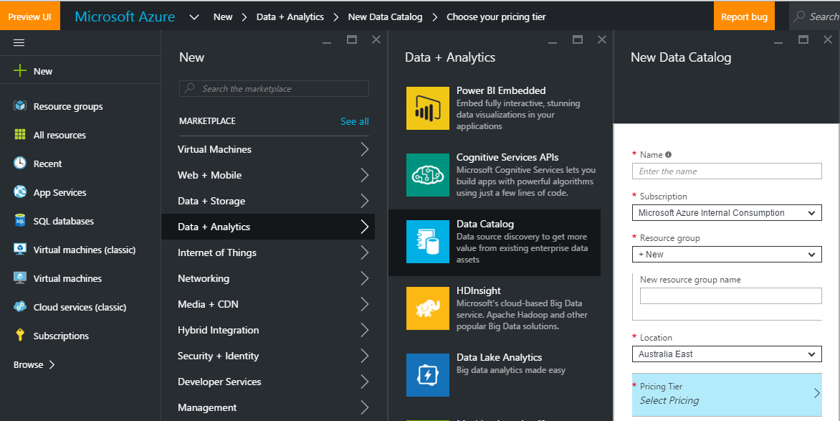
Figure 22: Provisioning an Azure Data Catalog

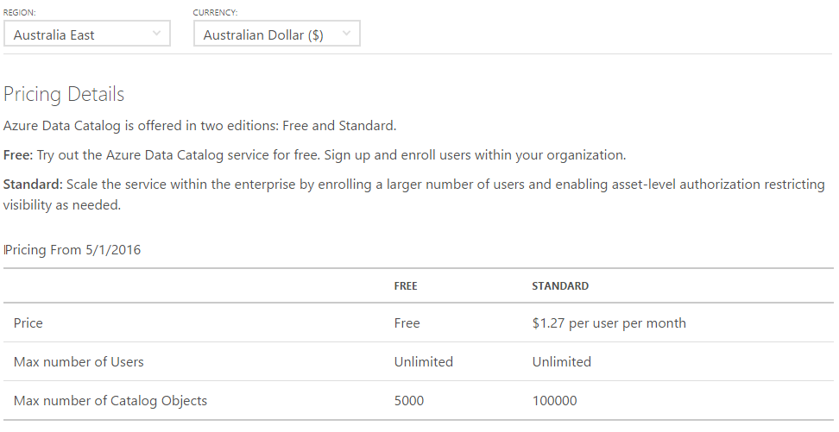
Figure 23: Azure Data Catalog Pricing

- Data Storage Products and Services
  - SQL Server
    - Overview
SQL Server is the premier Database Management System, recently announced by Garter as the Magic Quadrant leader for both Ability to Execute and Completeness of Vision, overtaking Oracle for the first time.
With over 25 years of product development, the latest release of SQL Server brings significant enhancements for BI and IM deployments, including;
- In-database Advanced Analytics with R – R is the language of Data Scientists, and for the first time, we can run R scripts inside the database engine
- Real-time Operational Analytics – By combining In-Memory Column-Store Indexes with In-Memory OLTP, we can run real-time analytics without impacting on the application performance
- T-SQL over Hadoop Data with Polybase – Polybase allows us to query Hadoop data using T-SQL, unifying relational and non-relational data
- Mobile BI – Through the acquisition of DataZen, SQL Server Reporting Services receives a very welcome “fresh coat of paint”, with sophisticated native mobile apps for iOS, Android and Windows devices
- Enhanced AlwaysOn – For the first time, we can automatically load-balance read workloads across multiple readable secondary copies of an AlwaysOn database, perfect for dealing with massive reporting workloads against mission critical databases
- Stretch Database – Automatically stretch the “cold” portion of large tables to Azure, while still being able to query the data when needed. This reduces local storage costs, while maintaining access to data for reporting
    - Best Use-Case Scenario
Compared to Azure SQL Database, covered next, SQL Server is best suited for instances in which the full power of the Database Management System is required. A few examples of this include;
- Deploying Data Quality Services, Master Data Services, Reporting Services, Integration Services, Analysis Services etc
- Requiring server-level features such as linked servers and extended stored procedures
- Data loads that exceed 1 TB
- Continued support for legacy applications currently running on SQL Server
    - Required Components
SQL Server can be run on-premises or in an Azure Virtual Machine.
  - Azure SQL Database
    - Overview
SQL Database is a relational database service in the cloud based on the market-leading Microsoft SQL Server engine, with mission-critical capabilities. SQL Database delivers predictable performance, scalability with no downtime, business continuity and data protection—all with near-zero administration. You can focus on rapid app development and accelerating your time to market, rather than managing virtual machines and infrastructure. Because it’s based on the SQL Server engine, SQL Database supports existing SQL Server tools, libraries and APIs, which makes it easier for you to move and extend to the cloud.
Azure SQL Database is available in two design options, elastic database pools and single databases, to create innovative designs. With elastic database pools, as demand changes, the databases in the pool automatically scale up and down for predictable performance, with no downtime and within a predictable budget. If you only have a few databases, you can choose single databases and dial performance up and down, still with no downtime. Either way you go—single or elastic—you’re not locked in, as both benefit from SQL Database’s mission-critical capabilities, performance guarantee and industry-leading 99.99% SLA.
Azure SQL Databases can be optionally geo-replicated for increased high availability and disaster recovery requirements. Geo-replicas are available in both Standard and Active modes.
Standard geo-replication creates an offline secondary database in a pre-paired Azure region within the same geographic area that is at least 500 miles away. Secondary standard geo-replication databases are priced at 0.75x of primary database prices. The cost of geo-replication traffic between the primary and the offline secondary is included in the cost of the offline secondary. Standard geo-replication is available for Standard and Premium tier databases.
Active geo-replication creates up to 4 online (readable) secondaries in any Azure region. Secondary active geo-replication databases are priced at 1x of primary database prices. The cost of geo-replication traffic between the primary and the online secondary is included in the cost of the online secondary. Active geo-replication is available for Premium tier databases.
Azure SQL Databases are provisioned by performance tier with each tier providing a certain number of Database Transaction Units (DTUs) and Storage. The Database Transaction Unit (DTU) is the unit of measure in SQL Database that represents the relative power of databases based on a real-world measure: the database transaction. We took a set of operations that are typical for an online transaction processing (OLTP) request, and then measured how many transactions could be completed per second under fully loaded conditions. A Basic database has 5 DTUs, which means it can complete 5 transactions per second, while a Premium P11 database has 1750 DTUs.
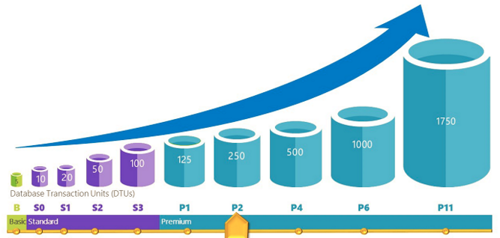
Figure 24: Azure SQL Database performance levels
Figure 25 shows the performance levels available for SQL Databases, along with the max database size, point-in-time restore options and various other performance levels.
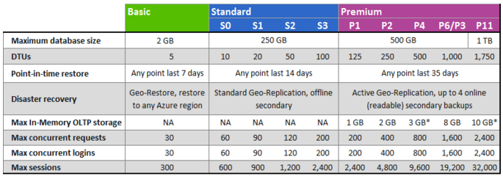
Figure 25: Azure SQL Database service tiers
In addition to creating and scaling a single database, you also have the option of managing multiple databases within an elastic pool. All of the databases in an elastic pool share a common set of resources. The performance characteristics are measured by elastic Database Transaction Units (eDTUs). As with single databases, pools come in three service tiers: Basic, Standard, and Premium. For pools, these three service tiers still define the overall performance limits and several features.
Pools allow elastic databases to share and consume DTU resources without needing to assign a specific performance level to the databases in the pool. For example, a single database in a Standard pool can go from using 0 eDTUs to the maximum database eDTU you set up when you configure the pool. This allows multiple databases with varying workloads to efficiently use eDTU resources available to the entire pool.
Figure 26 describes the characteristics of pool service tiers.
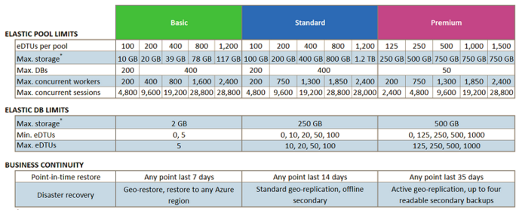
Figure 26: Azure SQL Database Elastic pool service tiers
References;
- https://azure.microsoft.com/en-us/documentation/articles/sql-database-technical-overview/
- https://azure.microsoft.com/en-us/pricing/details/sql-database/
- https://azure.microsoft.com/en-us/documentation/articles/sql-database-service-tiers/
    - Best Use-Case Scenario
Azure SQL Database is perfectly suited to new cloud-hosted applications where you don’t need to have server level control (operating system or database management system), and don’t want to spend any time on typical database administration activities such as backups, or maintaining availability groups for HA/DR planning.
    - Required Components
As per figure 27, Azure SQL Database can be easily provisioned in your Azure Subscription via the Portal. During creation, the portal will ask for;
- A Database Name
- The Resource Group to assign the database to
- The Source – Either a blank database or a sample
- The Server – Unlike traditional SQL Server, the server for a SQL Database is a logical concept, not a physical object that you need to maintain and administer
- The database collation, and
- The Pricing Tier
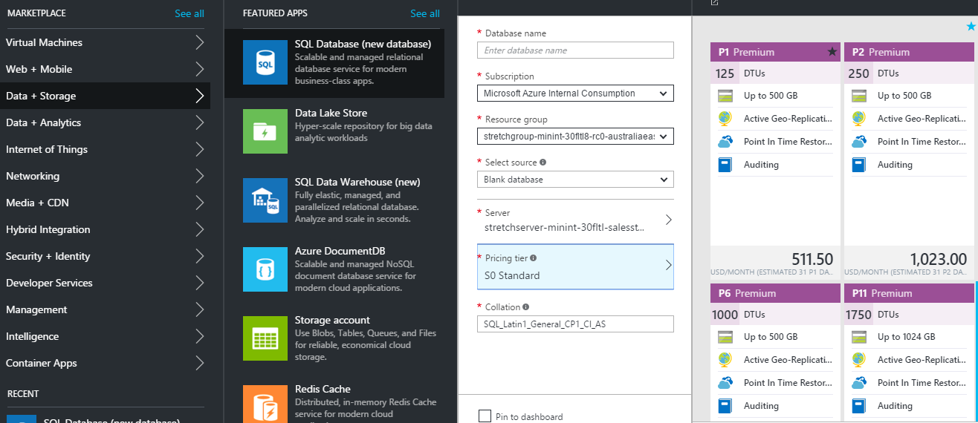
Figure 27: Azure SQL Database Provisioning Process

The estimated pricing, accurate as at April 2016, is show in figure 28.

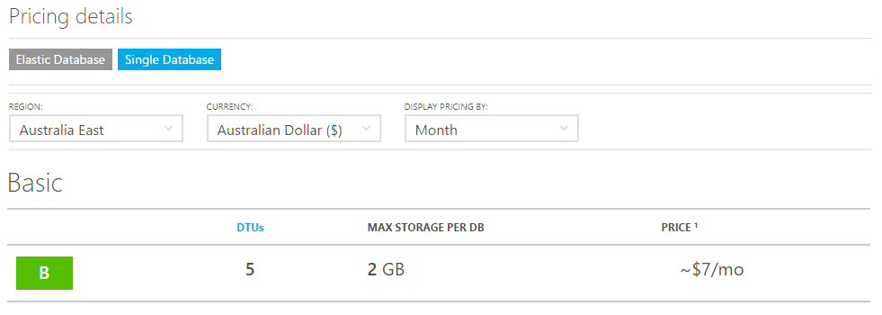
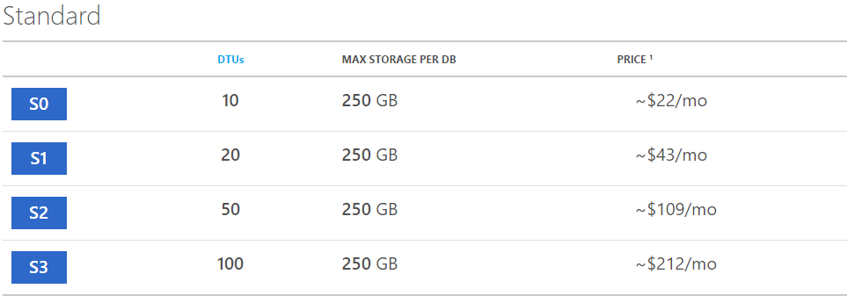
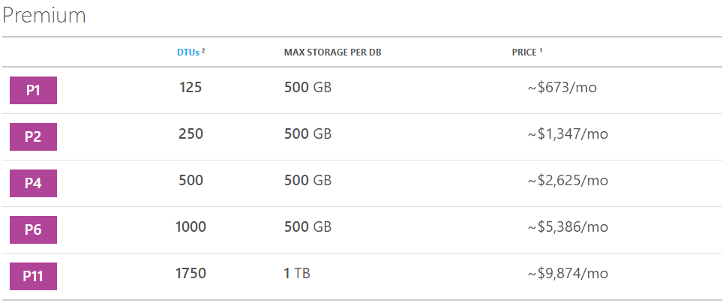
Figure 28: Azure SQL Database Pricing

  - Azure SQL Data Warehouse
    - Overview
Built on the Massively Parallel Processing (MPP) architecture, Azure SQL Data Warehouse (SQL DW) is a cloud-based, scale-out database capable of processing massive volumes of data - both relational and non-relational.
SQL DW is a cloud-based implementation of the SQL Server Parallel Data Warehouse (PDW) appliance, but with the advantage of elastic cloud computing, you have the ability to independently scale computing resources up or down, unlike an on-prem appliance device. And with a SQL Server heritage, you can develop with familiar T-SQL and tools.
SQL DW spreads your data across 60 shared-nothing storage and processing units. The data is stored in redundant, geo-replicated Azure Storage Blobs and linked to Compute nodes for query execution. With this architecture, we can take a divide and conquer approach to running complex T-SQL queries. When processing, the Control node parses the query, and then each Compute node "conquers" its portion of the data in parallel.
By combining our MPP architecture and Azure storage capabilities, SQL DW can:
- Grow or shrink storage independent of compute
- Grow or shrink compute without moving data
- Pause compute capacity while keeping data intact
- Resume compute capacity at a moment's notice
The SQL DW architecture, shown in figure 29, consists of several key components;
Control node: The Control node "controls" the system. It is the front end that interacts with all applications and connections. In SQL Data Warehouse, the Control node is powered by SQL Database, and connecting to it looks and feels the same. Under the surface, the Control node coordinates all of the data movement and computation required to run parallel queries on your distributed data. When you submit a TSQL query to SQL Data Warehouse, the Control node transforms it into separate queries that will run on each Compute node in parallel.
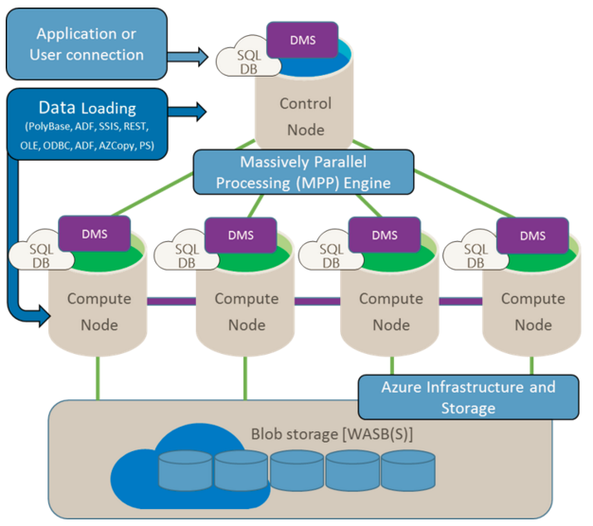
Figure 29: Azure SQL Data Warehouse Architecture
Compute Nodes: The Compute nodes serve as the power behind SQL Data Warehouse. They are SQL Databases which process your query steps and manage your data. When you add data, SQL Data Warehouse distributes the rows using your Compute nodes. The Compute nodes are also the workers that run the parallel queries on your data. After processing, they pass the results back to the Control node. To finish the query, the Control node aggregates the results and returns the final result.
Storage: Your data is stored in Azure Storage Blobs. When Compute nodes interact with your data, they write and read directly to and from blob storage. Since Azure storage expands transparently and limitlessly, SQL Data Warehouse can do the same. Since compute and storage are independent, SQL Data Warehouse can automatically scale storage separately from scaling compute, and vice-versa. Azure Storage is also fully fault tolerant and streamlines the backup and restore process.
Data Movement Service: Data Movement Service (DMS) is our technology for moving data between the nodes. DMS gives the Compute nodes access to data they need for joins and aggregations. DMS is not an Azure service. It is a Windows service that runs alongside SQL Database on all the nodes. Since DMS runs behind the scenes, you won't interact with it directly. However, when you look at query plans you will notice they include some DMS operations since data movement is necessary in some shape or form to run each query in parallel.

In addition to the divide and conquer strategy, the MPP approach is aided by a number of data warehousing specific performance optimizations, including:
- A distributed query optimizer and set of complex statistics across all data. Using information on data size and distribution, the service is able to optimize queries by assessing the cost of specific distributed query operations.
- Advanced algorithms and techniques integrated into the data movement process to efficiently move data among computing resources as necessary to perform the query. These data movement operations are built-in and all optimizations to the Data Movement Service happen automatically.
- Clustered columnstore indexes by default. By using column-based storage, SQL Data Warehouse gets up to 5x compression gains over traditional row-oriented storage, and up to 10x query performance gains. Analytics queries that need to scan a large number of rows work great on columnstore indexes.
Using SQL Data Warehouse with PolyBase gives users unprecedented ability to move data across their ecosystem, unlocking the ability to set-up advanced hybrid scenarios with non-relational and on-premises data sources.
Polybase is easy to use and allows you to leverage your data from different sources by using the same familiar T-SQL commands. Polybase enables you to query non-relational data held in Azure blob storage as though it is a regular table. Use Polybase to query non-relational data or to import non-relational data into SQL Data Warehouse.
Polybase is agnostic in its integration. It exposes the same features and functionality to all the sources that it supports. The data read by Polybase can be in a variety of formats, including delimited files or ORC files. PolyBase can be used to access blob storage that is also being used as storage for an HD Insight cluster, giving you cutting-edge access to the same data with relational and non-relational tools.
References;
- https://azure.microsoft.com/en-us/documentation/articles/sql-data-warehouse-overview-what-is/
- https://azure.microsoft.com/en-us/pricing/details/sql-data-warehouse/
    - Best Use-Case Scenario
Azure SQL Data Warehouse is best used in large Data Warehousing environments that will benefit from the scale-out approach of the Massively Parallel Processing (MPP) architecture. Further, as Azure SQL DW runs in the cloud, you avoid the large Cap-Ex investment in an appliance, and further benefit by being able to independently scale compute and storage, and even pause compute to minimise operating costs.
    - Required Components
As per figure 30, Azure SQL Data Warehouse can be easily provisioned in your Azure Subscription via the Portal. During creation, the portal will ask for;
- A Database Name
- The Resource Group to assign the database to
- The Source – Either a blank database or a sample
- The Server – Unlike traditional SQL Server, the server for a SQL Database is a logical concept, not a physical object that you need to maintain and administer, and
- The Pricing Tier
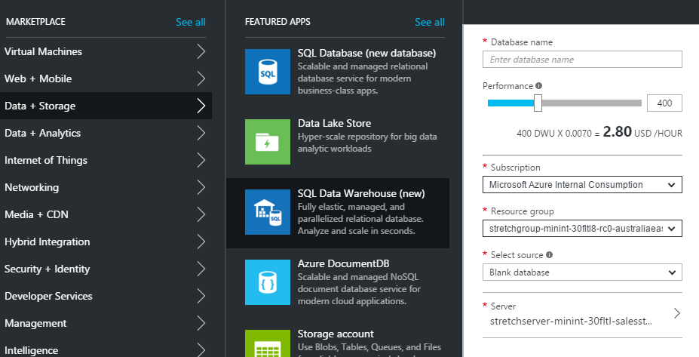
Figure 30: Provisioning Azure SQL DW
Azure SQL DW compute and storage are billed separately. Storage rates are based on the standard page blob rates. Compute usage is represented by Data Warehouse Units (DWU). The DWU costs are shown in figure 31 (accurate as at April 2016). They can be scaled up/down as needed, and SQL DW will dynamically adjust. Prices shown are in AUD, based in the Sydney data centre.
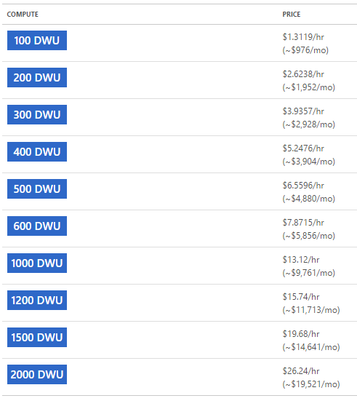
Figure 31: Azure SQL DW Pricing

  - Azure Data Lake
    - Overview
Your data is a valuable asset to your organization and has both present and future value. Because of this, all data should be stored for future analysis. Today, this is often not done because of the restrictions of traditional analytics infrastructure, like the pre-definition of schemas, the cost of storing large datasets, and the propagation of different data silos. To address this challenge, the data lake concept was introduced as an enterprise-wide repository to store every type of data collected in a single place. For the purpose of operational and exploratory analytics, data of all types can be stored in a data lake prior to defining requirements or schema.
In the previous section, we looked at Azure SQL Data Warehouse, a product designed to store structured, relational data. In contrast, Azure Data Lake is designed to store data of any type. Imagine a situation where you want to capture and store the audio recordings of customers interacting with a call centre. Storing large audio files inside a relational database is possible, but not optimal, and is likely to be very expensive. With Azure Data Lake, we can store those types of files very economically, and at a later point, perform speech to text conversion, and then perform sentiment analysis on the phone calls, to predict customer churn.
As shown in figure 32, Data Lake is comprised of the Data Lake Store, and Data Lake Analytics.
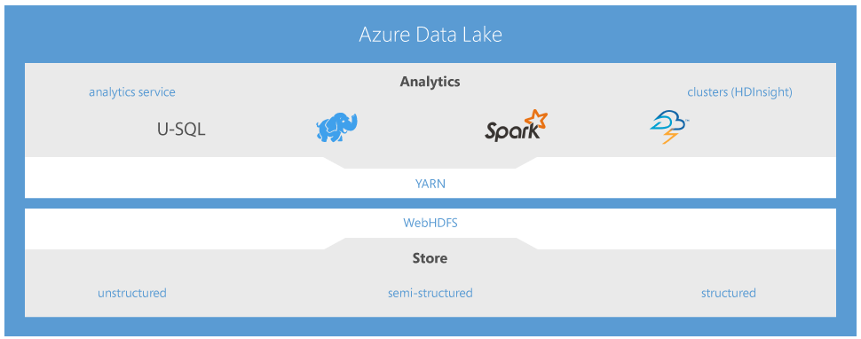
Figure 32: Azure Data Lake Architecture
The Data Lake Store, illustrated in figure 33, is best described as a hyper-scale repository for big data analytics workloads. Key features include;
- A Hadoop distributed file system running in the Azure cloud
- No fixed limits on size
- Store both relational and non-relational data in their native format
- Specialized hardware providing massive throughput to increase analytics performance
- High durability, availability and reliability
- Azure Active Directory access control
- Full encryption and auditing built in
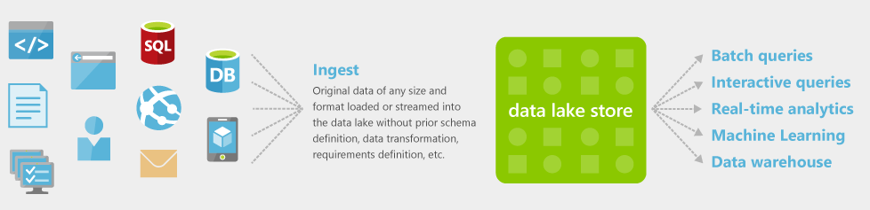
Figure 33: Azure Data Lake Store
Data Lake Store has no fixed limits on account size or file size. While other cloud storage offerings might restrict individual file sizes to a few terabytes, Data Lake Store can store very large files that are hundreds of times larger. At the same time, it provides very low latency read/write access and high throughput for scenarios like high-resolution video, scientific, medical, large backup data, event streams, web logs, and Internet of Things (IoT). Collect and store everything in Data Lake Store without restriction or prior understanding of business requirements.
Data Lake Store is a distributed file store allowing you to store relational and non-relational data without transformation or schema definition. This lets you store all of your data and analyze them in their native format.
Once data is loaded into the Store, Data Lake Analytics can query the data when required.
Data Lake Analytics dynamically provisions resources and lets you do analytics on exabytes of data. When the job completes, it winds down resources automatically, and you pay only for the processing power used. As you increase or decrease the size of data stored or the amount of compute used, you don’t have to rewrite code. This lets you focus on your business logic only and not on how to process and store large datasets. It also takes away the complexities normally associated with big data in the cloud and ensures that Data Lake will meet your current and future business needs.
One of the top adoption challenges of big data technologies is obtaining the skills and capabilities needed to be productive. With Data Lake Analytics, use U-SQL, a query language that blends the declarative nature of SQL with the expressive power of C#. The U-SQL language is built on the same distributed runtime that powers the big data systems inside Microsoft. Millions of SQL and .NET developers can now process and analyze all of their data using skills they already have. Figure 34 includes a few code examples of the U-SQL language.
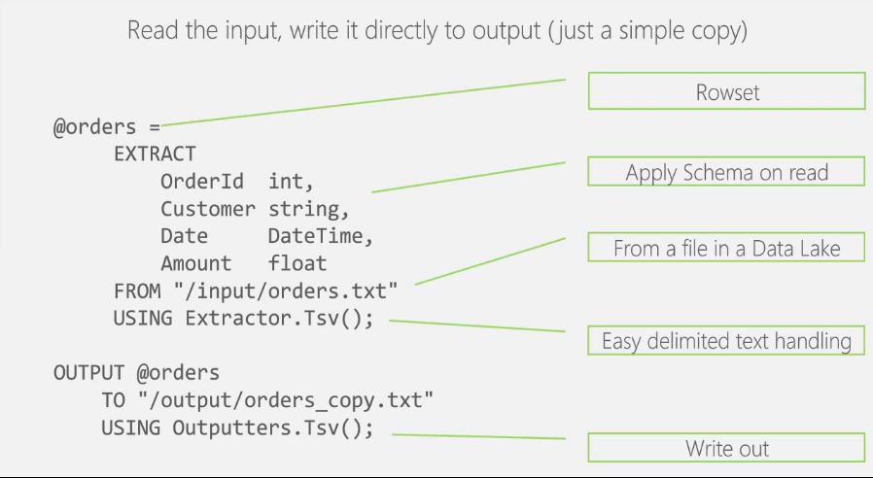
Figure 34: Simple U-SQL Example
As mentioned earlier, we can now use the expressive power of C# to query items in the data lake. Two examples of that are shown below in figures 35 and 36. In figure 35, we call an intrinsic .NET method, and in figure 36, we use our own C# method in a U-SQL query against our data lake.

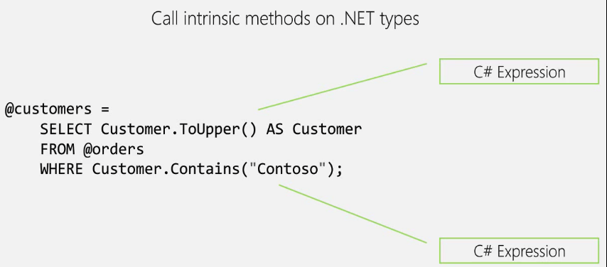
Figure 35: U-SQL Query using an intrinsic .NET method

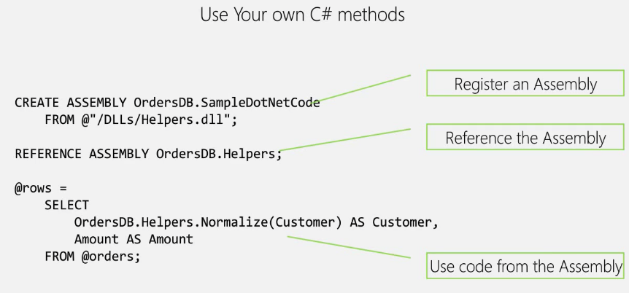
Figure 36: U-SQL Query using a custom ..NET method
Azure Data Lake Analytics is not limited to querying data in Azure Data Lake Store. As shown in figure 37, we can use U-SQL to query data across a variety of stores.
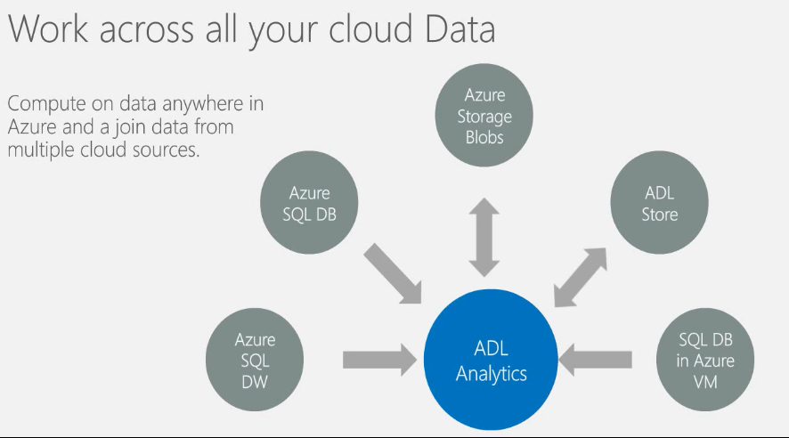
Figure 37: Data Lake Analytics
References;
- https://azure.microsoft.com/en-us/services/data-lake-store/

    - Best Use-Case Scenario
Azure Data Lake is best used in scenarios where there’s a large amount of both relational and non-relational data that may not have an immediate business value, but should be kept for later analysis when the need arises.
Data Lake is also perfect for Data Scientists. In the classic BI ETL development approach, data is extracted from source systems, transformed, and then loaded into a Data Warehouse/Mart. This is perfect for business users to be presented with a nice, easy to understand business semantic layer. However, Data Scientists often want to consume the raw data, in its original form, as a sandpit area to prove or disprove a hypothesis. A cleansed subset of data in a Data Mart is too pure for a Data Scientist, they need access to the raw data to uncover data patterns that may not have been anticipated by the BI developer.
It’s in the Data Lake that high value business insights are often uncovered, and once they are, the downstream structured Data Marts can receive that data in a form that business users can understand. Think of the Data Lake as the massive body of dirty water that the Data Scientists drink from, and the downstream Data Marts as the clean, filtered glass of water fit for broader consumption by the business.
    - Required Components
As at April 2016, the Data Lake service is preview mode. As per figure 38, you can request access to the service through the Azure Portal.
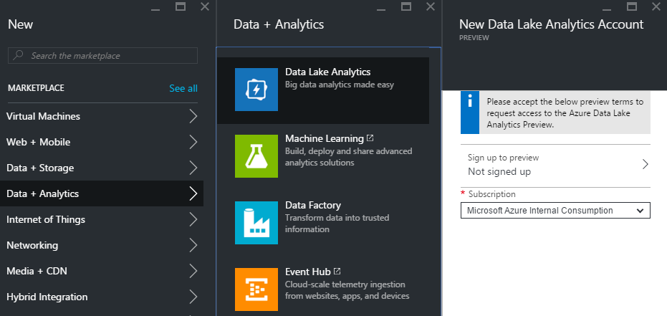
Figure 38: Provisioning Azure Data Lake
  - Azure Blob Storage
    - Overview
Azure Blob storage is a service that stores file data in the cloud. Blob storage can store any type of text or binary data, such as a document, media file, or application installer.
In the previous section we covered Azure Data Lake, which is very similar in that it can store any type of file in its native format, however, there are some key differences between the two;
- File Size; Azure Blob storage comes in two types, Page Blobs and Block Blobs. Page Blobs are limited to 1TB, and Blob Blobs 200GB. In contrast, Data Lake Store does not limit the size of any uploaded object
- Throughput; Azure Blob Storage has a target throughput of up to 60MB per second or up to 500 requests per second. In contrast, Azure Data Lake runs on specialised hardware for maximum throughput and minimal latency
- Hadoop Integration; Azure Blob Storage is a generic store for multiple use cases, where Data Lake Storage is optimised for Big Data Analytics
- Cost; Given the specialist nature of Data Lake Storage, the costs of generic Azure blob storage is less. As at April 2016, the Data Lake Store is still in preview, so no cost comparison has been included here
The costs for Azure Blob Storage, as at April 2016, are shown in Figure 39
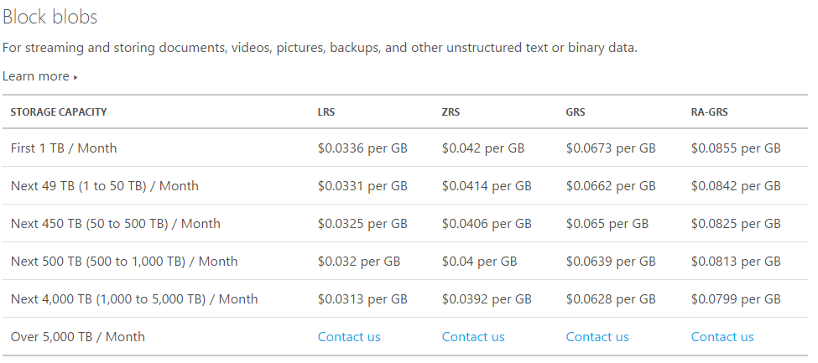
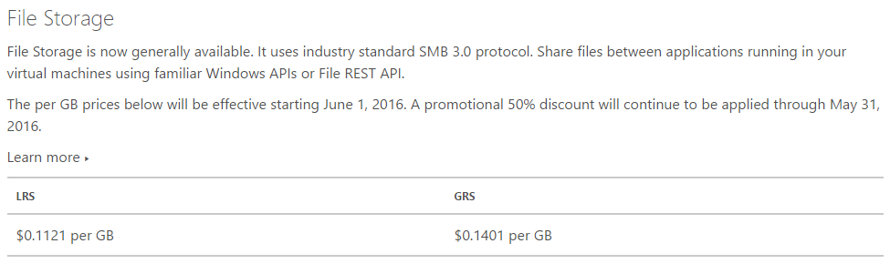
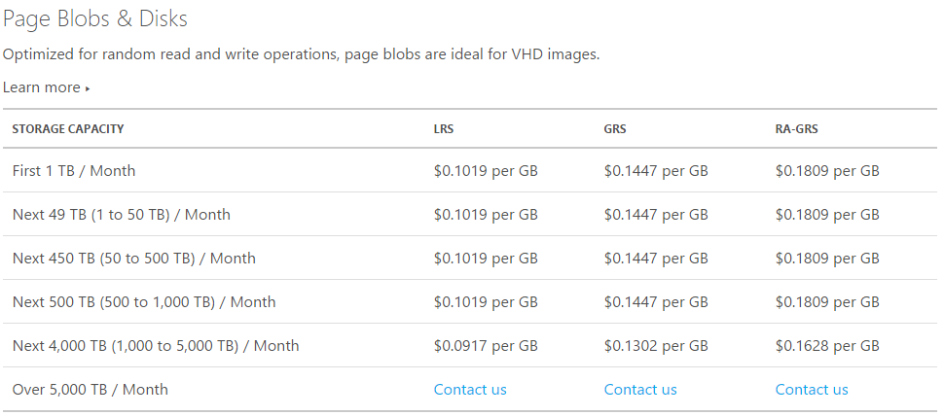
Figure 39: Azure Blob Storage Costs

The above costs make reference to LRS, ZRS, GRS and RA-GRS. These are the data redundancy options for the storage blobs, as described in figure 40.
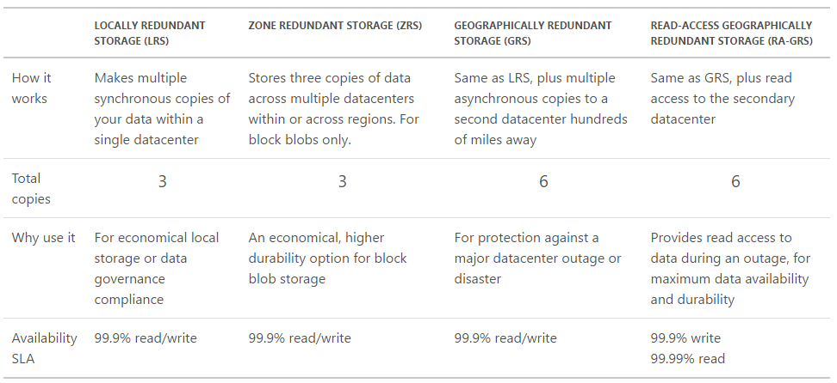
Figure 40: Azure Blob Redundancy Options

The other storage option is Premium Storage, which is a high performance Solid State Drive (SSD) based Storage designed to support I/O intensive workloads with significantly high throughput and low latency. With Premium Storage, you can provision a persistent disk and configure its size and performance characteristics to meet your application requirements.
Page Blob Premium Storage is currently offered in three disk sizes: P10 (128 GB), P20 (512 GB) and P30 (1,024 GB), as shown in figure 41.
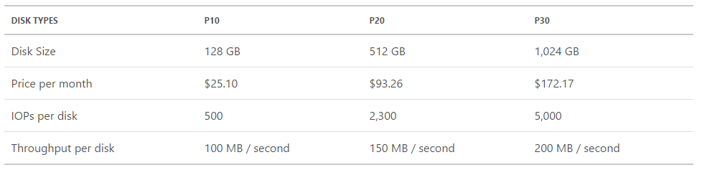
Figure 41: Azure Premium Storage Costs
References;
- https://azure.microsoft.com/sv-se/documentation/articles/storage-dotnet-how-to-use-blobs/
- https://azure.microsoft.com/en-us/pricing/details/storage/
    - Best Use-Case Scenario
Azure Blob Storage is a fundamental component of any cloud-based workload that requires persistent storage.
    - Required Components
Azure Blob Storage is provisioned within a Storage Account, which is a core component required when creating various Azure objects such as Virtual Machines. Provisioning a storage account is shown in figure 42.

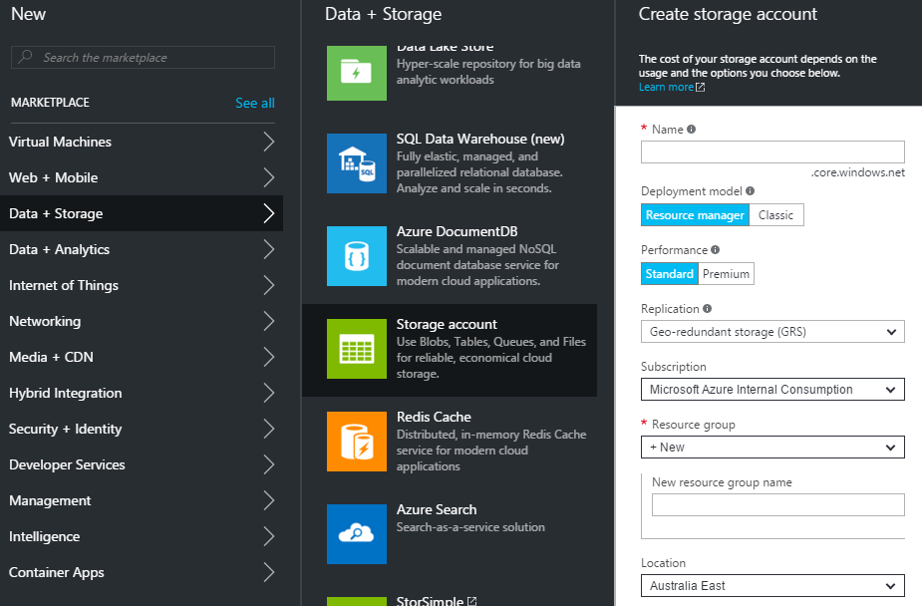
Figure 42: Provisioning an Azure Storage Account
  - DocumentDB, Redis Cache & Azure Table Storage
    - Overview
For many years, relational databases such as SQL Server and Oracle were the data-layer foundation of applications. Strict schema definition and table relationships defined a database, and applications honoured those constraints when saving data.
In today’s rapid pace of application development involving structured, semi-structured, unstructured and polymorphic data, relational databases often struggle to cope with the agility and scale demands placed on them.
In contrast, the data models of NoSQL databases allow for rapidly changing data and schema, object oriented programming and geographically distributed scale-out architectures. Today’s commonly used NoSQL databases include MongoDB, Cassandra, Redis, CouchDB and HBase. Microsoft offers several NoSQL options including DocumentDB, Azure Table Storage and Redis Cache.
DocumentDB is a fully managed NoSQL database-as-a-service built for fast and predictable performance, high availability, automatic scaling, and ease of development. Its flexible data model, consistent low latencies, and rich query capabilities make it a great fit for web, mobile, gaming, and IoT applications that need seamless scale.
Azure Table Storage is a service that stores structured NoSQL data in the cloud. Table storage is a simple key/attribute store with a schema-less design. Because Table storage is schema-less, it's easy to adapt your data as the needs of your application evolve. Access to data is fast and cost-effective for all kinds of applications. Table storage is typically significantly lower in cost than traditional SQL for similar volumes of data.
Azure Redis Cache is based on the popular open-source Redis. It gives you access to a secure, dedicated Redis cache, managed by Microsoft, and accessible from any application within Azure.

Both Azure Table Storage and Redis Cache provide simple, yet highly performant and scalable Key/Value store, where DocumentDB can work with complex JSON objects and also supports familiar T-SQL syntax.
References;
- https://azure.microsoft.com/en-us/documentation/articles/documentdb-introduction/
- https://azure.microsoft.com/en-gb/documentation/articles/storage-dotnet-how-to-use-tables/
- https://azure.microsoft.com/en-gb/documentation/learning-paths/redis-cache/
    - Best Use-Case Scenario
NoSQL database technologies such as DocumentDB are best used as data stores for applications that require massive scale and the flexibility of a schema-free design, allowing for rapid, agile changes in development direction. DocumentDB delivers on that, while at the same time allowing complex queries using the familiar T-SQL language.
    - Required Components
NoSQL solutions such as DocumentDB can be provisioned in the Azure Portal under the Data + Storage area by simply providing a Resource Group to provision within. Figure 43 shows the provisioning process for a DocumentDB database.
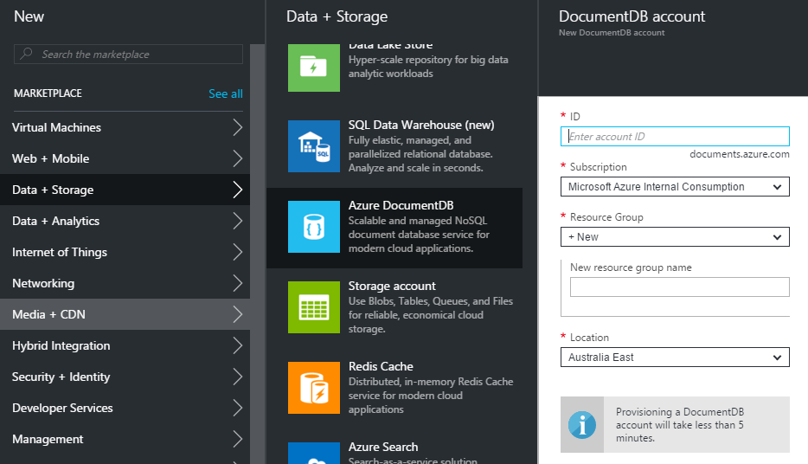
Figure 43: Provisioning a DocumentDB database

- Analytics Products and Services
  - SQL Server Analysis Services
    - Overview
SQL Server Analysis Services (SSAS), part of the SQL Server family since its introduction as “OLAP Services” in SQL Server 7, enables semantic layers (cubes) to be built over a Data Warehouse/Mart, providing a simpler business interface for applications such as Microsoft Excel, whilst also improving performance by pre-aggregating measures by commonly sliced dimensions.
In SQL Server 2012, a tabular version of SSAS was introduced, joining the multidimensional version. The tabular version enables data models developed by business users in Excel/Power Pivot to be upgraded to SSAS Tabular. This is perfect for enabling business users the flexibility of self-service data modelling, while ensuring an upgrade path for frequently used data models to an IT managed service.
    - Best Use-Case Scenario
Analysis Services cubes are perfect in providing fast, easy to understand data models for “slice and dice” and pivot table/chart reporting for business users. In additional to Microsoft Excel, there’s a large variety of 3rd party reporting applications built to work with SSAS cubes. Power BI, discussed in section 5.3, can also consume data from SSAS cubes, making them an ideal BI & IM data model foundation.
The Tabular version of Analysis Services is perfectly complimented by self-service data modelling tools, providing a great foundation for Bi-Modal BI & IM.
    - Required Components
SQL Server Analysis Services can be run on-premises or in an Azure Virtual Machine.
  - SQL Server Reporting Services
    - Overview
First introduced in 2003 as an add-on to SQL Server 2000, SQL Server Reporting Services (SSRS) became a first-class member of the SQL Server family in the 2005 release.
In describing their reporting roadmap moving forward, Microsoft describes the following types of reports;
Paginated reports built with SQL Server Report Builder or SQL Server Data Tools. Paginated reports allow for exact placement of elements on a page and are capable of complex display logic for creating printed reports or online operational reports. Paginated/operational reports have been a popular, invaluable foundation for day-to-day reporting and analytics for over a decade. These reports will continue to be a standard report type.
Interactive reports built with Power BI Desktop. Power BI Desktop, described in section 5.3, is a contemporary visual data discovery application and the next generation of our Power View technology. It generates HTML5-based reports, ensuring compatibility across all modern browsers.
Mobile reports are based on Datazen technology, acquired by Microsoft in 2015. Microsoft believe dedicated reports optimized for mobile devices and form factors provide an optimal experience for users accessing BI reports on mobile devices. By specifically designing reports for different mobile form factors, Microsoft deliver on their promise and enable users to get business insights from any device.
Analytical reports and charts created with Excel. Excel is the most widely used analytical tool today and it will continue to be an important report type, critical to our solution on-premises and in the cloud.

SQL Server Reporting Services has long provided the foundation for “Paginated” reports, but as per figure 44, Microsoft is positioning SSRS as the foundation for all four types of reports. In the 2016 release of SQL Server;
- The DataZen technology is baked into SSRS, enabling mobile reporting capability with native mobile apps for iOS, Android and Windows devices, along with HTML 5 rendering for browsers
- Power BI desktop reports can be published to SSRS server for fully on-prem Power BI deployments
- Existing tools, such as Report Builder and SQL Server Data Tools will continue to be supported moving forward
- SSRS Reports can be pinned to Power BI Dashboards

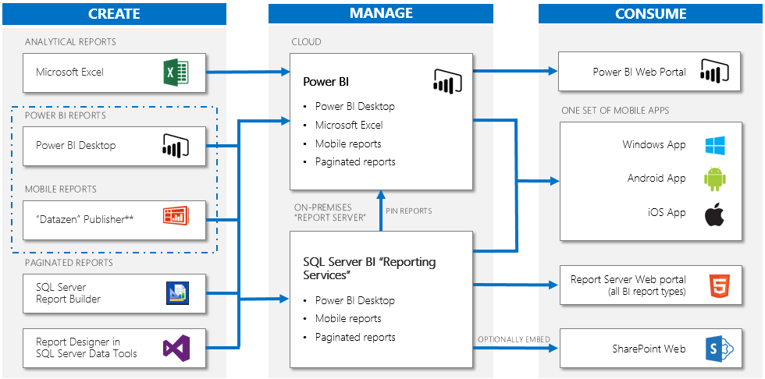
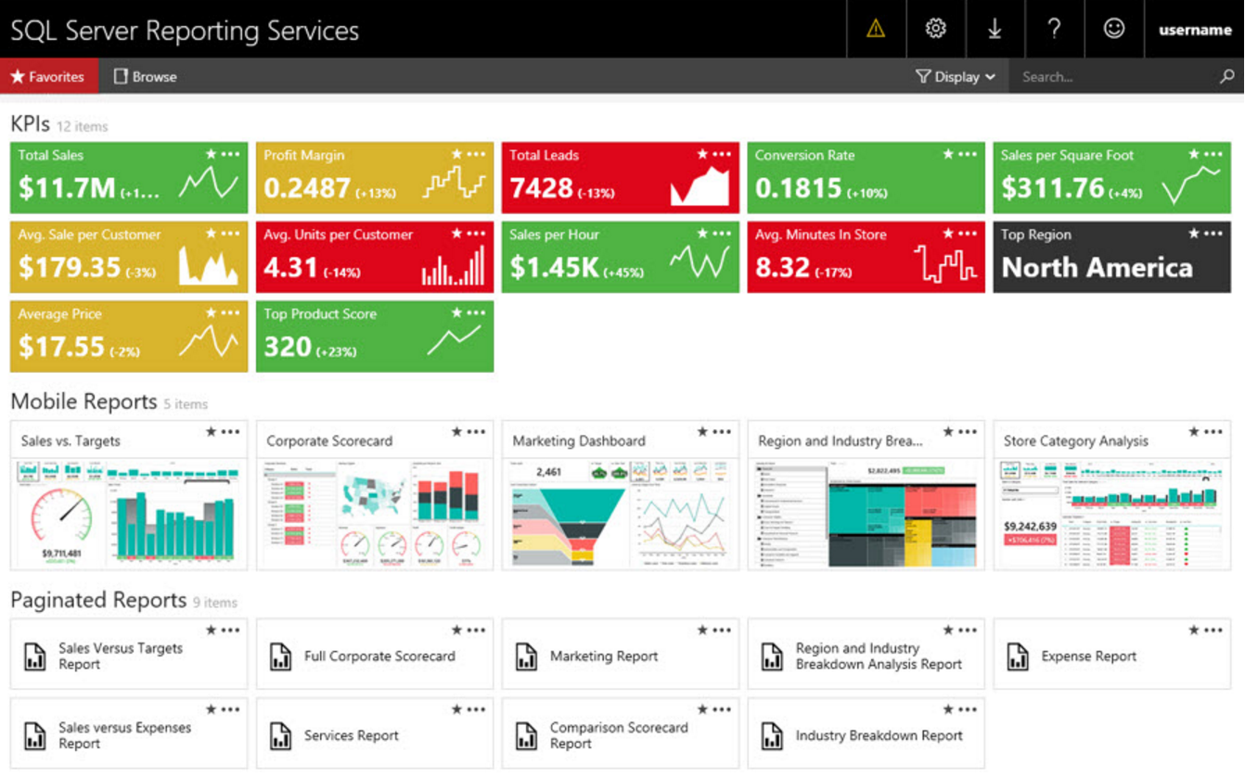
Figure 44: SQL Server Business Intelligence Roadmap
    - Best Use-Case Scenario
SQL Server Reporting Services has been a fundamental component of Microsoft-centric BI & IM strategies for a long time, and with the recent investments in the platform which unify paginated, interactive, mobile and analytical reports, this will continue to be the case in the years ahead.
    - Required Components
SQL Server Reporting Services can be run on-premises or in an Azure Virtual Machine.
  - Power BI
    - Overview
Beginning with the Power Pivot Excel add-in in 2010, followed by Power View, Power Query and Power Map, Power BI has grown to become a first-class self-service analytics tool.
The Power BI ecosystem is comprised of;
- Power BI Desktop; A Windows application for connecting to data sources, performing both simple and advanced data modelling, and creating immersive visualisations. Power BI supports data connections to all the main data sources, as well as SharePoint lists, JSON files, Web Pages and SaaS applications such as SalesForce.com, Google Analytics and CRM Online
- PowerBI.com; A web portal for sharing solutions created in Power BI desktop. Once a desktop solution is uploaded, other users can interact with it, or create new visualisations from scratch in the browser against the data model contained within the uploaded solution. Users can pin items of interest from a variety of reports to their own custom dashboard. As per figure 44, Power BI solutions can also be deployed on-prem starting with the SQL Server 2016 release
- On-Prem Data Connectivity; Uploaded solutions in PowerBI.com can be configured to refresh their data periodically, or, connect directly to the data source, either on-prem, or cloud hosted. The Power BI Personal and Enterprise Gateways are used for on-prem data source connectivity
- Mobile Applications; Power BI offers native mobile apps for iOS, Android and Windows, as well as HTML5 for modern browsers
- Open Source Visualisations; Power BI uses d3.js for visualisations, and offers the ability to create your own, or download community visualisations, opening up an incredible array of visualisation possibilities
- Q & A; Power BI includes the natural language Q & A feature, enabling questions to be typed, or via Cortana, spoken, using conversational language, rather than code
- Quick Insights; Insights are often buried in the data, out of sight. The quick insights feature brings these to the surface, exposing previously unknown outliers and/or trends not already obvious
- External Sharing; Power BI solutions can be shared with external parties outside your organisation
- API; Power BI includes APIs which opens up opportunities such as real-time dashboards from streaming data such as IOT devices. An example of this is shown in figure 45, which is for the SR520 bridge in Seattle.
- Power BI Embedded; Finally, Power BI solutions can be embedded inside applications, ensuring the visualisation and data modelling sophistication of Power BI can be extended to any application

The high level architecture of Power BI is shown in figure 46.

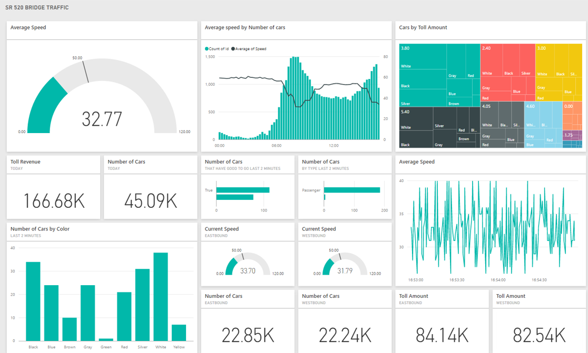
Figure 45: Power BI Real-Time Traffic Dashboard
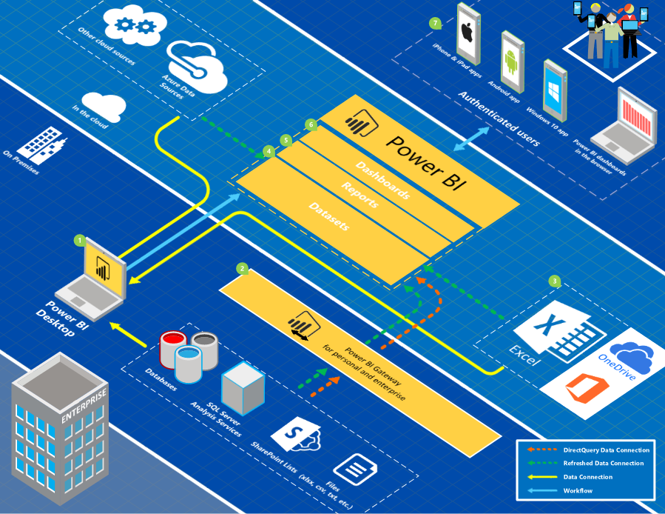
Figure 46: Power BI Architecture

    - Best Use-Case Scenario
With tight integration to all other parts of the Microsoft BI stack, Power BI is the industry leading BI solution which brings a huge amount of value to any BI & IM strategy. As shown in figure 47, it’s available in 2 editions, FREE and PRO. The pricing below is RRP price only.
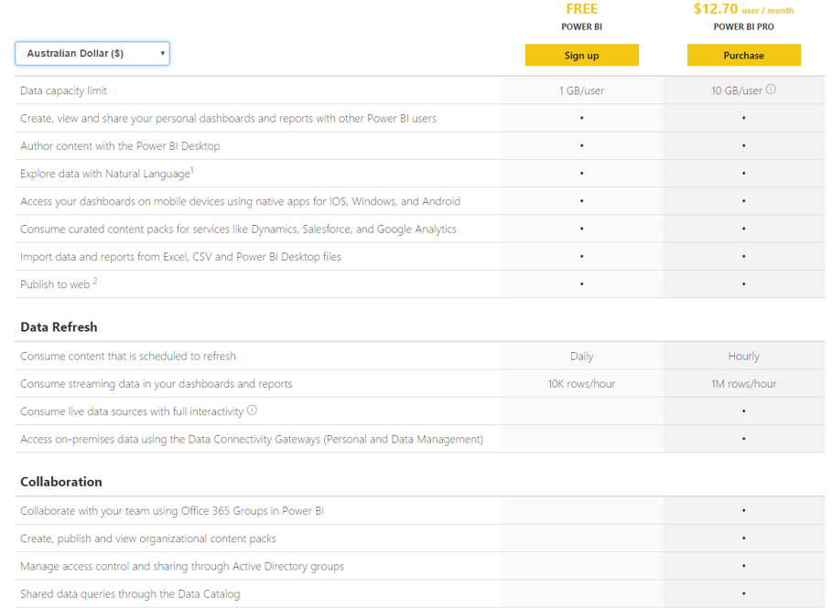
Figure 47: Power BI Pricing Options

    - Required Components
Power BI is provisioned through PowerBI.com. It integrates with your existing Azure Active Directory, and PRO licenses are assigned through the Office 365 admin portal.
  - Azure Machine Learning
    - Overview
Azure Machine Learning (AML) is a fully cloud-managed service that enables you to build predictive analytics models. Once the model is trained and you have confidence in the predictions, you can deploy the model as a web service, and use it to operationalise predictions as part of the day-to-day business.
Azure Machine Learning Studio includes many built-in packages and support for custom code, using Python or R, including thousands of community submitted R packages from the Comprehensive R Archive Network (CRAN) site. Designed for applied machine learning, it uses best-in-class algorithms, shown in figure 48, and a simple drag-and-drop web interface, shown in figure 49.
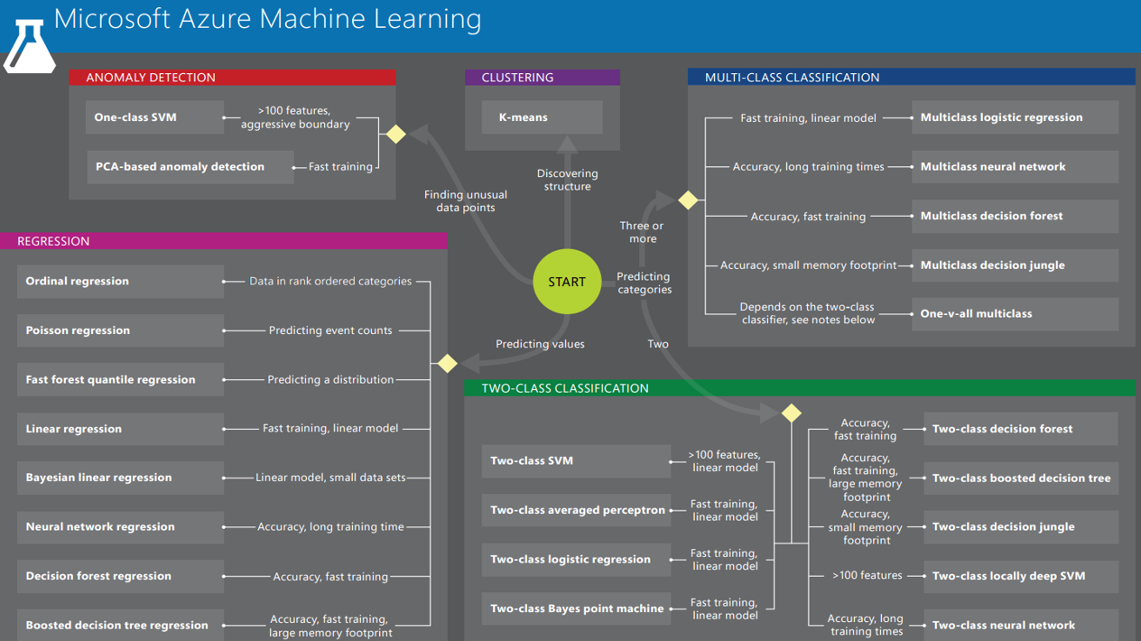
Figure 48: Azure Machine Learning Algorithms
Models are evaluated for accuracy before being deployed as a web service to operationalise the predictive model. An example of a regression algorithm evaluation is shown in figure 50.
Azure Machine Learning provides a number of templates for common scenarios, providing a great way to get up and running quickly, before customisation for your own unique requirements. A sample of the available templates are shown in figure 51.

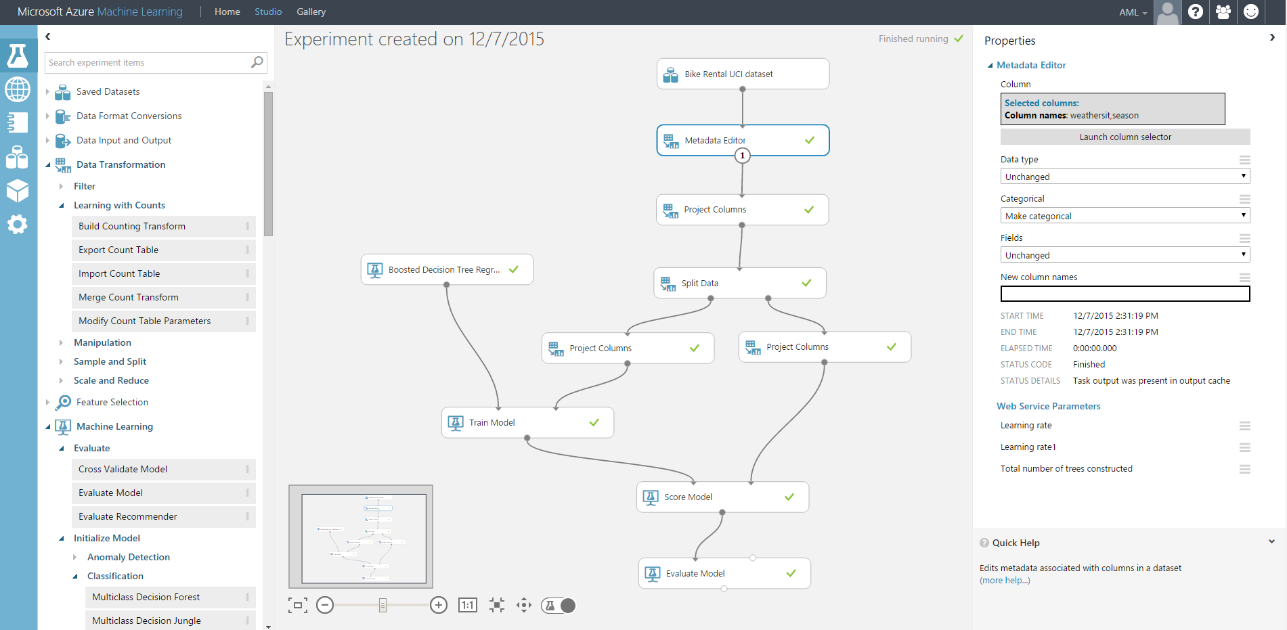
Figure 49: Azure Machine Learning Development Interface
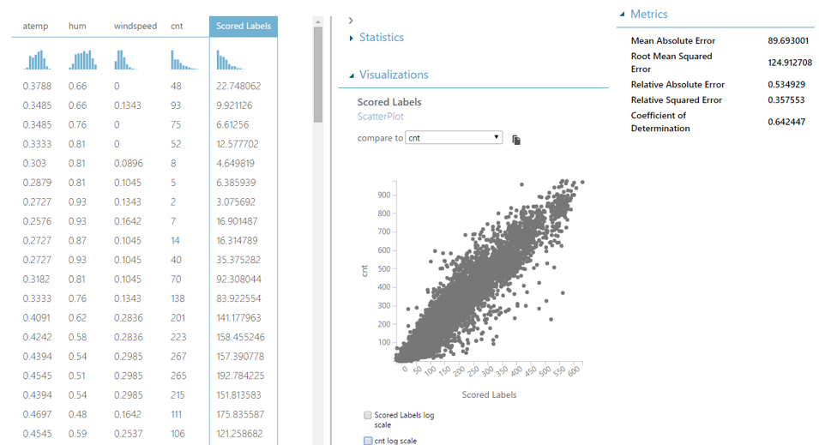
Figure 50: Azure Machine Learning Model Evaluation
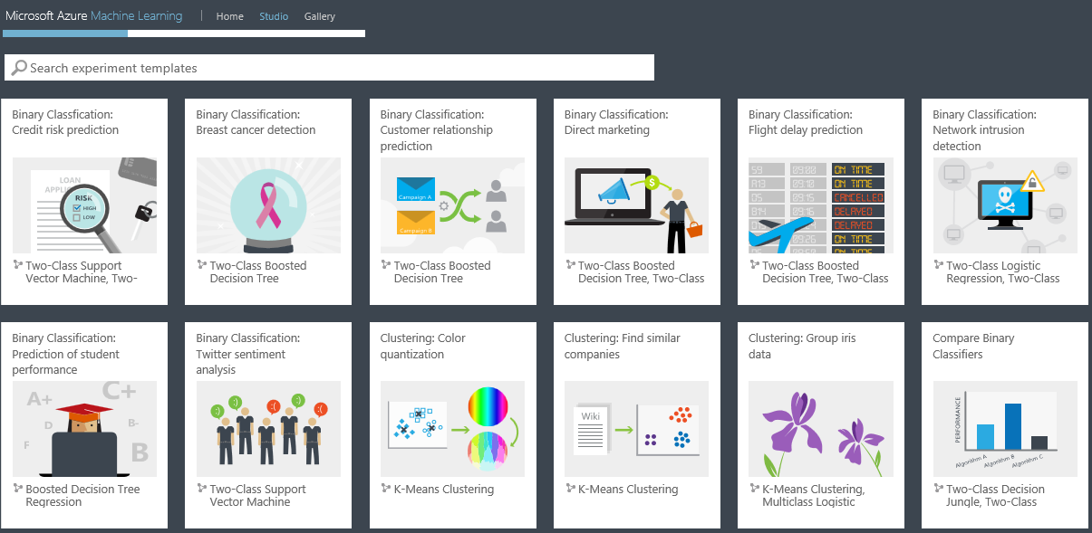
Figure 51: Azure Machine Learning Templates
Machine Learning is offered in two tiers: Free and Standard. Features by tier are compared in figure 52.
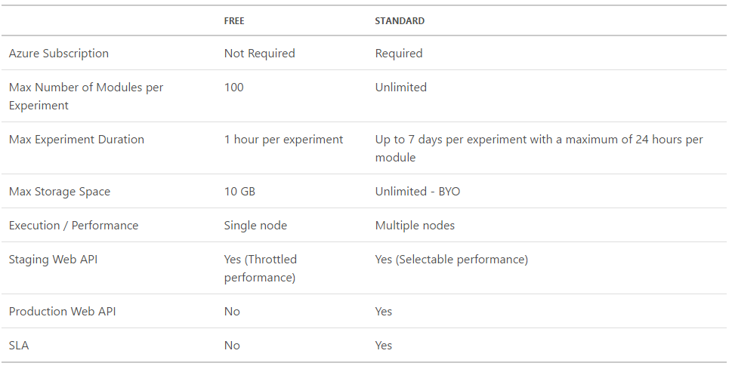
Figure 52: Azure Machine Learning Editions
The standard tier pricing, as at April 2016, is shown is figure 53.
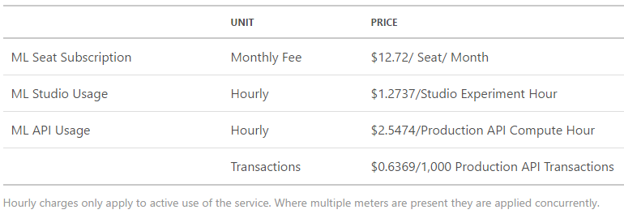
Figure 53: Azure Machine Learning Pricing
References;
- https://azure.microsoft.com/en-us/pricing/details/machine-learning/
    - Best Use-Case Scenario
Azure Machine Learning is the ideal choice for operationalising predictive analytics models through a fully managed cloud platform. Alternatives for predictive analytics include R script, inside SQL Server, or Data Mining, a component of SQL Server Analysis Services but these options lack the ease of development and deployment when compared to Azure Machine Learning.
    - Required Components
Azure Machine Learning is provisioned via the Azure Portal, as shown in figure 54.
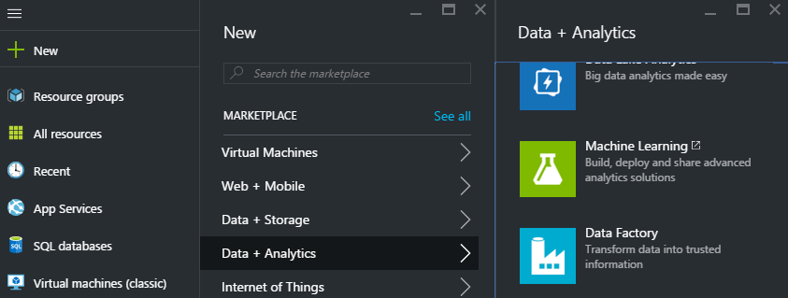

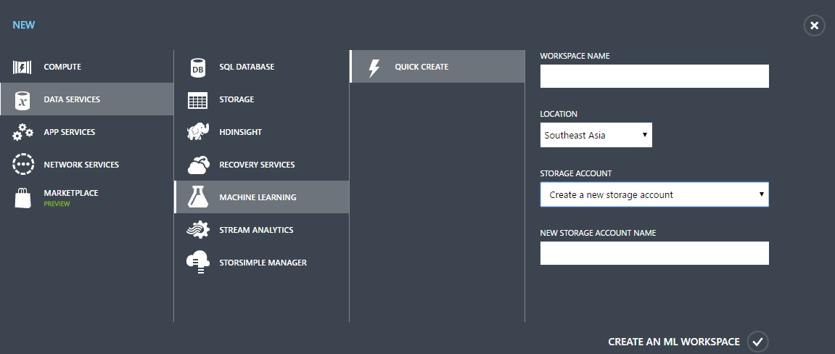
Figure 54: Provisioning Azure Machine Learning
  - Azure HDInsight
    - Overview
HDInsight is a managed Apache Hadoop, Spark, R, HBase and Storm cloud service. As such, you avoid the need to buy and maintain clusters of machines, while being able to scale to petabytes on-demand. Process structured, semi-structured and unstructured data, develop in Java, .Net and other languages, and analyse with Power BI and Excel.
A snapshot of supported Apache projects is presented in figure 55.
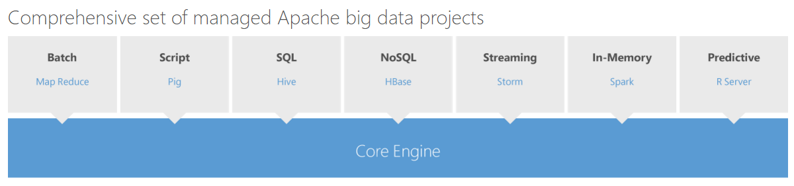
Figure 55: Apache Projects on HDInsight
References;
- https://azure.microsoft.com/en-gb/services/hdinsight/
    - Best Use-Case Scenario
HDInsight is ideally used by organisations with current or planned Apache big data projects who want to avoid the cost of maintaining their own hardware and software.
    - Required Components
A HDInsight Cluster is provisioned via the Azure Portal, as shown in figure 56.
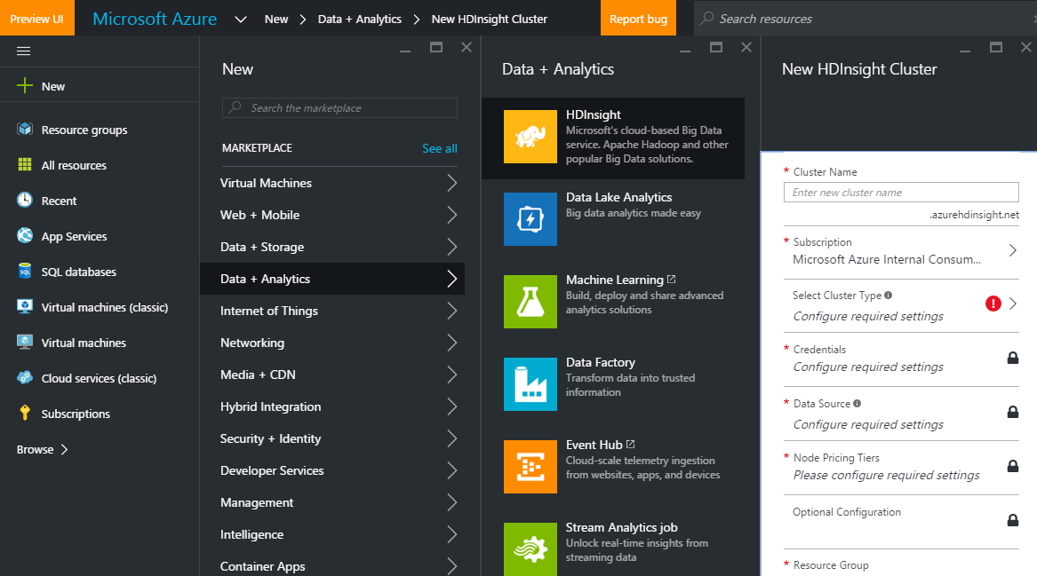
Figure 56: Provisioning a HDInsight Cluster
The first selection choice when configuring the cluster is choosing the cluster type. As per figure 57, you can provision a Hadoop, HBase, Storm, Spark or R Server on Spark cluster, and depending on the cluster type, choose between Linux or Windows. Other configuration items include entering the credentials, resource group and pricing tier.
HDInsight is offered in both Standard and Premium editions. The Premium edition provides predictive modelling and machine learning with Microsoft R Server.
Pricing for HDInsight is charged per node with full details at https://azure.microsoft.com/en-us/pricing/details/hdinsight/
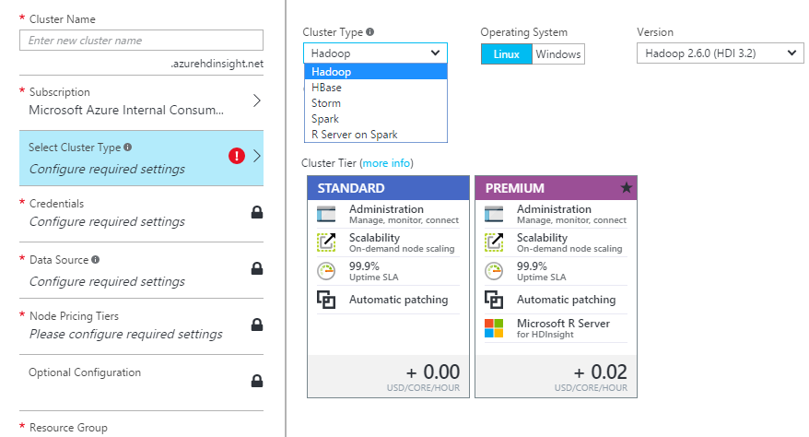
Figure 57: HDInsight Cluster Configuration
  - Azure Event Hub, Stream Analytics & IOT Suite
    - Overview
While separate, independent services, Azure Event Hubs and Stream Analytics are often used together to ingest events in real-time, perform analytics on the stream of data, and take action, common in IOT scenarios.
Azure Event Hubs is a highly scalable publish-subscribe service that can ingest millions of events per second and stream them into multiple applications, such as Stream Analytics, to process and analyse the massive amounts of data produced by your connected devices and applications.
Stream Analytics processes ingested events in real-time, comparing multiple streams with historical values and models. It can detect anomalies, transform incoming data, trigger alerts when a specific error or condition appears in the stream and display this real-time data in Power BI dashboards, as we saw earlier in figure 45.
For IOT specific scenarios, Microsoft also offers the IOT Hub, which enables bi-directional communication with IOT devices. IOT Suite includes IOT Hub, Stream Analytics, Azure Machine Learning, Power BI, and Notification Hubs, which enable push notifications to be sent to any platform such as iOS, Android, Windows or Kindle devices.
Used together through the IOT Hub, these services enable scenarios such as this;
- Streams of data from hundreds of IOT devices ingested, in real-time, via IOT Hub
- The data streams are aggregated in tumbling windows, for example, the last 5 minutes, using Stream Analytics
- Aggregated data is sent from Stream Analytics to Azure Machine Learning, where the data is processed against a previously trained predictive model
- Depending on the predictive outcome, a message can be sent back to an IOT device, for example, to switch it off, or any other action necessary
- A push message can be sent to a mobile device, for example, to alert an on-call officer to an event
- All the while, a real-time Power BI dashboard can be updated with the events and aggregations of interest
References;
- https://azure.microsoft.com/en-gb/services/event-hubs/
- https://azure.microsoft.com/en-gb/services/stream-analytics/
- https://azure.microsoft.com/en-us/services/iot-hub/
    - Best Use-Case Scenario
These services, working together, are best used in harnessing massive streams of data from IOT devices and taking appropriate actions based on trained predictive models. Perfect use-cases include predictive maintenance, remote monitoring and real-time anomaly detection, for example, unusual banking transactions that may indicate money laundering.
    - Required Components
Each of the services covered above can be provisioned separately in the Azure Portal, or via https://www.azureiotsuite.com/ for an integrated IOT solution.
  - Cortana Intelligence Gallery
In previous sections, we’ve covered individual products and services that span Data Storage, Information Management and Analytics. When combined together, these products and services deliver incredibly powerful solutions. In light of this, Microsoft have made available Solution Templates which deliver end-to-end, industry-specific solutions as a starting point from which customisations can be applied.
Available via https://gallery.cortanaintelligence.com/solutionTemplates, solution templates including Vehicle Telemetry, Predictive Maintenance and Energy Demand Forecasting are provided. Each template includes the individual components, as well as Azure Data Factory code to orchestrate the end-to-end solution.
Figure 58 shows the solution template for Demand Forecasting for Energy, which includes Event Hubs, Stream Analytics, Machine Learning, Data Factory, HDInsight, Blob Storage, Azure SQL Database and Power BI.
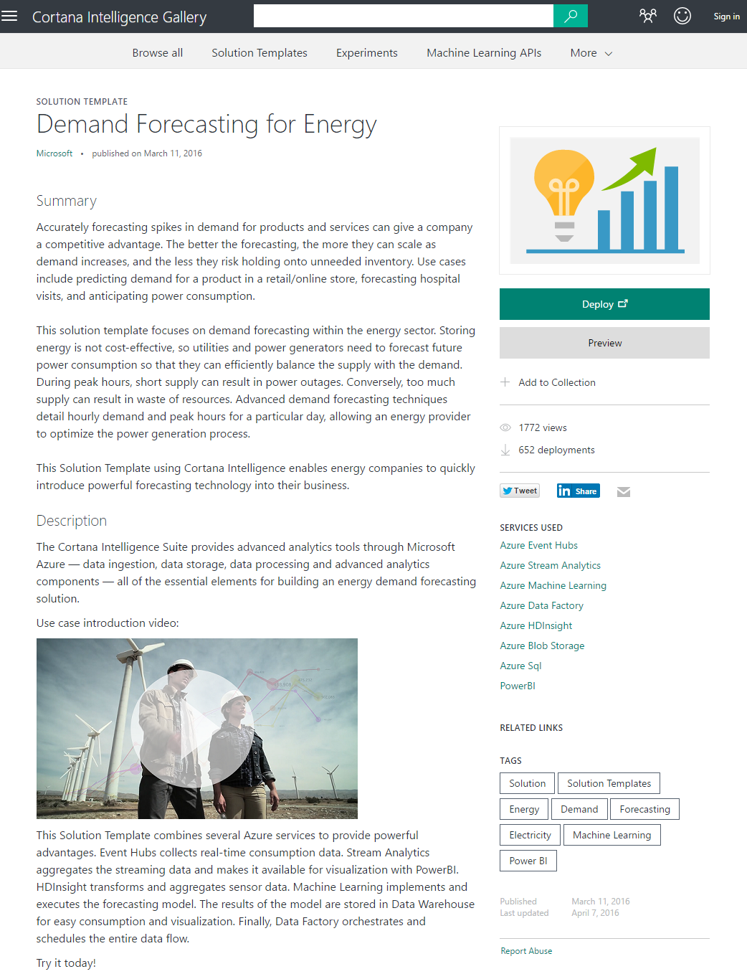
Figure 58: Cortana Intelligence Solution Template
To complete the Intelligence offering, Microsoft also offers a series of cognitive services, including Text Analytics, Emotion APIs, Sentiment Analysis, Facial Recognition APIs, Speech APIs, and many more. Each of these services can be integrated into any solution.
A typical example of how these cognitive services could be included in a BI & IM project is applying a Speech to Text function to Call Centre recordings stored in Azure Data Lake, and then performing sentiment analysis to predict the likelihood of customer churn, based on the phone call and other data on the customer.

- Example BI & IM Architecture
  - Background
Most organisations start their BI & IM platform journey with a high level overview of what they want to achieve, with progressive steps along the way to implement the vision. We’ll follow a similar approach here for our fictitious Acme Inc., who currently operate a fully on-prem solution, as per figure 59, with the following components;
- CRM, Sales & Inventory databases running on Oracle and SQL Server
- SQL Server Data Warehouse, receiving Sales and CRM data via SSIS ETL packages
- A SQL Server Analysis Services (SSAS) Cube, containing Sales and CRM measures, with shared and separate dimensions
- Inventory data is not contained in either the Cube or Data Warehouse
- Reporting Services reports
- Business users running Pivot Charts and Tables in Microsoft Excel
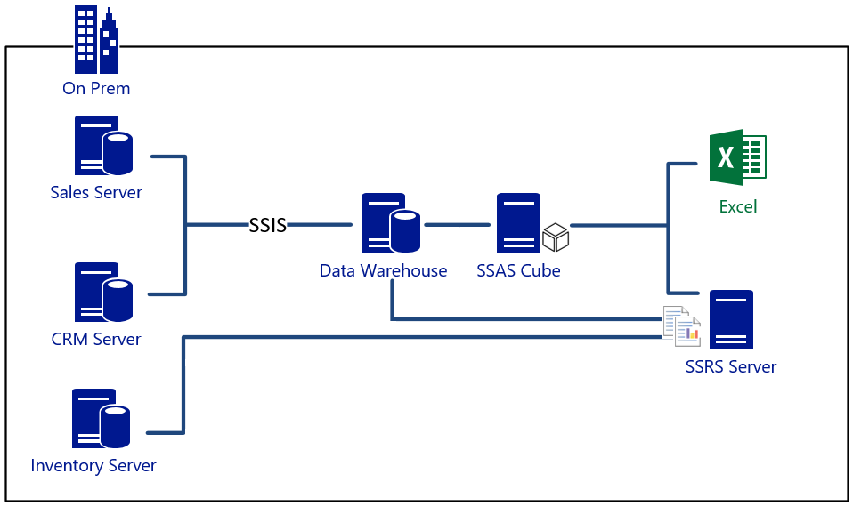
Figure 59: Acme Inc – Current State BI Architecture
The following pain points have been identified with the current design;
- Incomplete data for self-service reporting: Business users connect to the cube using Excel but it doesn’t contain any inventory data. Some users have managed to receive a point-in-time inventory extract and have shared it with other users via email or USB copies. This is insecure, and the data is out of date. The IT department are too busy to include Inventory Data in the cube, and are considering blocking USB keys to increase security. Business users are increasingly frustrated that they cannot access all required data sets
- Conflicting data: Corporate SSRS reports include data from all sources, but the product codes are inconsistent between the Inventory and Sales systems
- Poor data quality: There are known issues with the quality of data in the CRM system – some phone numbers are missing area codes and many email addresses are invalid. This is having a detrimental effect on marketing campaigns’ effectiveness
- Ineffective collaboration: Business users find it difficult to collaborate on reporting efforts. There are a few power users with great Excel skills, but their efforts are difficult to share with the broader user community. They are currently placing excel files on a network drive, but other users frequently find the file in use and locked. There is also a desire for reporting on mobile devices, currently lacking
- Data latency; As the volume of sales data grows, users are finding the data in the cube is falling further behind. The ETL load times into the Data Warehouse are getting longer, and the cube build is extending into the beginning of the day. The cube is often unavailable until mid-morning for reporting, and the data is at least 12 hours out of date
- Inventory stock levels don’t reflect sales: Due to data quality issues, and the difficulty in cross-reporting sales with inventory, the warehouse is over-stocked in undersold products, and running short on popular products
- Lack of voice analytics; Customer service calls to the call centre are recorded, but no analytics is being done on the phone conversations. Acme want to correlate these calls with buying behaviour
Acme want to improve their solution in the following ways;
- A real-time sales dashboard
- Better data quality for improved marketing campaign effectiveness
- Consistent product codes across all systems for accurate cross-system reporting
- A collaboration portal enabling business users to securely share self-service reports, taking the load off the IT department
- A way for business users to easily discover and consume data
- Take advantage of predictive analytics to better stock the warehouse
- Make better use of call centre voice recordings
- Take advantage of the scalability, agility and cost-effectiveness of the cloud
- Introduce a Mobile BI capability
- Reduce overheads and Capex by moving their applications from on-prem hosted and maintained solutions to web-hosted PaaS or SaaS solutions

The BI & IM platform redesign will take place in 3 stages. Stage one will lay the platform for cloud adoption and move reporting to Power BI. Stage two will address data quality and retention issues, introduce PaaS services, and begin using predictive analytics. Stage three will implement real-time analytics.
  - Stage 1
In stage 1, Acme implement and configure Azure Active Directory (AAD) as a foundational step in their cloud strategy. Among other benefits, this enables single-sign for their users, and row-level security in their Power BI dashboards.
Following the AAD implementation, Acme implement the following changes shown in figure 60
- Following a review of their Data Governance policy, Acme implement Azure Data Catalog to enable the publishing of meta-data from their data assets. They publish meta-data from their Inventory Database, their Data Warehouse and their SSAS Cube. Meta-data includes selected tables, views and columns, measures and dimension attributes. To enable the catalog to be as useful as possible, the data steward annotates the meta-data with the various terms that business users may use when searching for attributes and columns, and includes documentation on each published item to help business users understand the data, how recent the data is, and who the organisational contact is if users want to request access to the data
- Power users, who previously created Excel solutions, now user Power BI desktop. They search the Azure Data Catalog for the data of interest, and are able to easily find any data published by the Data Steward using a variety of search terms. Once a user has found the data of interest in the catalog, they can choose to consume it in a tool of their choice, in this case, Power BI desktop. At the point of data consumption, Azure Data Catalog automatically redirects Power BI desktop to the data source, but this step is seamless to the user. In effect, Data Catalog tells Power BI Desktop where to find the data, by providing it with the connection string. If the user has the appropriate permissions, the data is consumed in Power BI desktop
- The Power Users perform data modelling and visualisations in Power BI desktop, before publishing the solution to the Acme Power BI Portal
- The broader business user community can now consume reports from their Acme Power BI portal, including the ability to view reports on their mobile devices (iOS, Android or Windows), set threshold alerts on measures of interest and receive toast notifications when the thresholds are breached. Users can also create their own reports in the browser against the data model contained in the uploaded Power BI solution. Groups of users can now easily collaborate on reports together in Power BI group workspaces
- Solutions uploaded to Power BI can contain either a copy of the consumed data, or a direct connection to it. In both cases, the Power BI Gateway (Personal or Enterprise) enables the data to either be periodically refreshed, or, the reports connect directly to the on-prem data in real-time
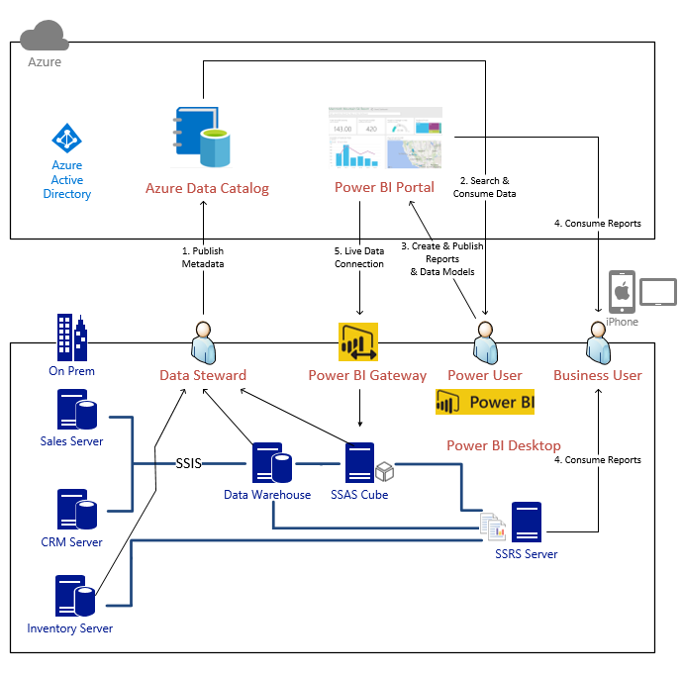
Figure 60: BI Re-architecture – Stage 1
At the end of stage 1, Acme inc. have laid the foundations for cloud adoption with Azure Active Directory and improved their BI platform in the following ways;
- Secure visibility of data for self-service reporting: Business users can now easily find the data they require through the Azure Data Catalog. They no longer need to email files to each other, share data on USB sticks or any other insecure method. The data consumed through the Catalog redirects to the source as specified by the Data Steward as part of the meta-data publishing process. If they don’t have access to the data, they can check the data source documentation included in the Catalog by the Data Steward for the process to gain access
- Improved collaboration: Business users have their own Power BI group workspaces where they can upload Power BI reports, work on them together, and share them with other users as required
  - Stage 2
In Stage 2, Acme continue their cloud adoption by making the following incremental changes from Stage 1
- The Sales and CRM systems are implemented as Azure SQL Database, replacing their on-prem server-based solutions. They use the SQL Server Migration Assistant (SSMA) for Oracle to assist them in migrating the CRM system from Oracle
- They implement their Data Warehouse in Azure SQL Data Warehouse
- They change their ETL to use Azure Data Factory to load Inventory, Sales and CRM data into Azure SQL Data Warehouse, replacing their on-prem SSIS solution
- They implement the Data Management Gateway to enable Data Factory to access the On-Prem Inventory Database
- Power BI is now configured to source data, in real time, from Azure SQL Data Warehouse, replacing the need for the On-Prem SSAS server
- They store the call centre recordings in Azure Data Lake for later analysis
- The SSRS Server is implemented as an IaaS Virtual Machine in Azure
- A SQL Server 2016 IaaS Virtual Machine is created in Azure to run SQL Server Data Quality Services and Master Data Services
- They develop and train an Azure Machine Learning model to predict future sales and required inventory levels in the warehouse. Data Factory orchestrates the retraining of the model periodically
Their stage 2 design is shown in figure 61.

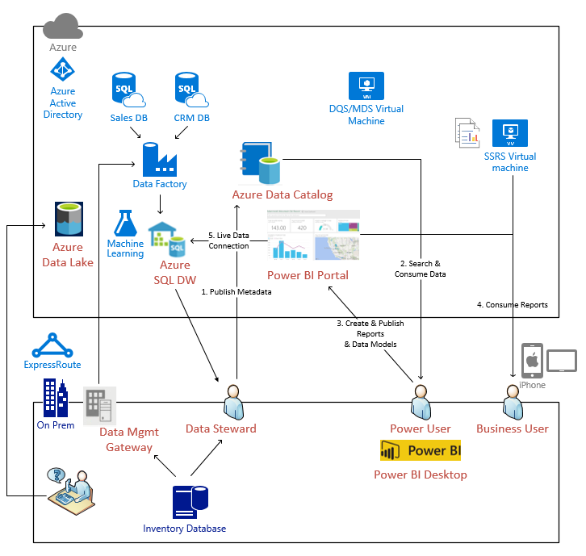
Figure 61: BI Re-architecture – Stage 2
At the end of stage 2, Acme have the beginnings of a sophisticated BI & IM platform with following capabilities now in place;
- Consistent data: Acme have implemented Master Data Services, ensuring key data is consistent across all of their systems
- Consistent data quality: Acme have implemented Data Quality Services, ensuring key CRM data is of a high quality and suitable for use in marketing campaigns
- Data latency; Power BI now sources its data directly from the Azure Data Warehouse, bypassing the on-prem Cube build process and the resulting data latency. Views are developed in Azure SQL Data Warehouse to provide a Semantic layer for reporting in Power BI, and as sales increase, Acme can simply dial up the DWU in Azure SQL Data Warehouse to provide the required performance
- Inventory stock levels reflect expected demand: The Machine Learning model developed in Azure Machine Learning looks at historical sales, the time of year, upcoming marketing campaigns in CRM and various other factors to forecast expected product demand. The results of these predictions are used to adjust the inventory ahead of predicted demand
- Voice analytics; Acme are now storing the raw audio file from call centre customer phone calls in their Data Lake. They plan on hiring a Data Scientist to use the Microsoft Speech to Text APIs to convert the phone calls to text, perform sentiment analysis and create a Machine Learning Model to use the results, along with other data, to predict customer churn and plan targeted customer retention activities
  - Stage 3
In the final stage, Acme add real-time dashboarding and analytics to complete their BI & IM vision.
- They capture real-time sales data from POS devices in all of their stores, and stream the data to Azure where it’s ingested in Azure Event Hubs
- They use Stream Analytics to analyse the data, in real-time, using Machine Learning Models to detect unusual buying patterns and alert local store staff where appropriate
- The sales data is pushed directly into a real-time Power BI dashboard using the Power BI APIs. Regional staff monitor the dashboards and use the information to plan short-term tactical marketing if appropriate trends begin to emerge
The completed platform design is shown in figure 62.
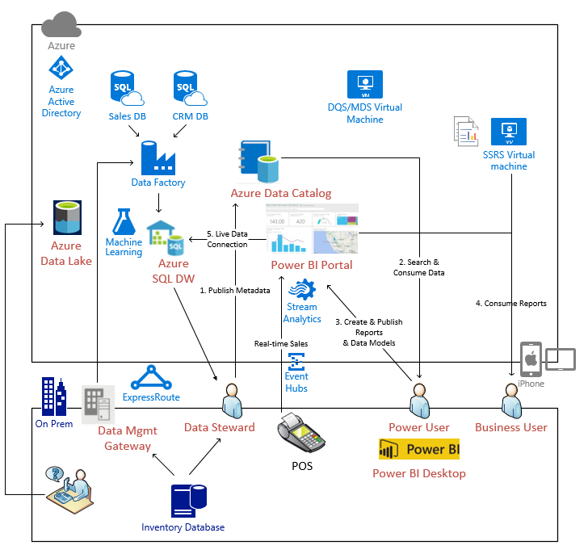
Figure 62: Completed BI Re-architecture

Appendix A: Azure Service Availability (April 2016)
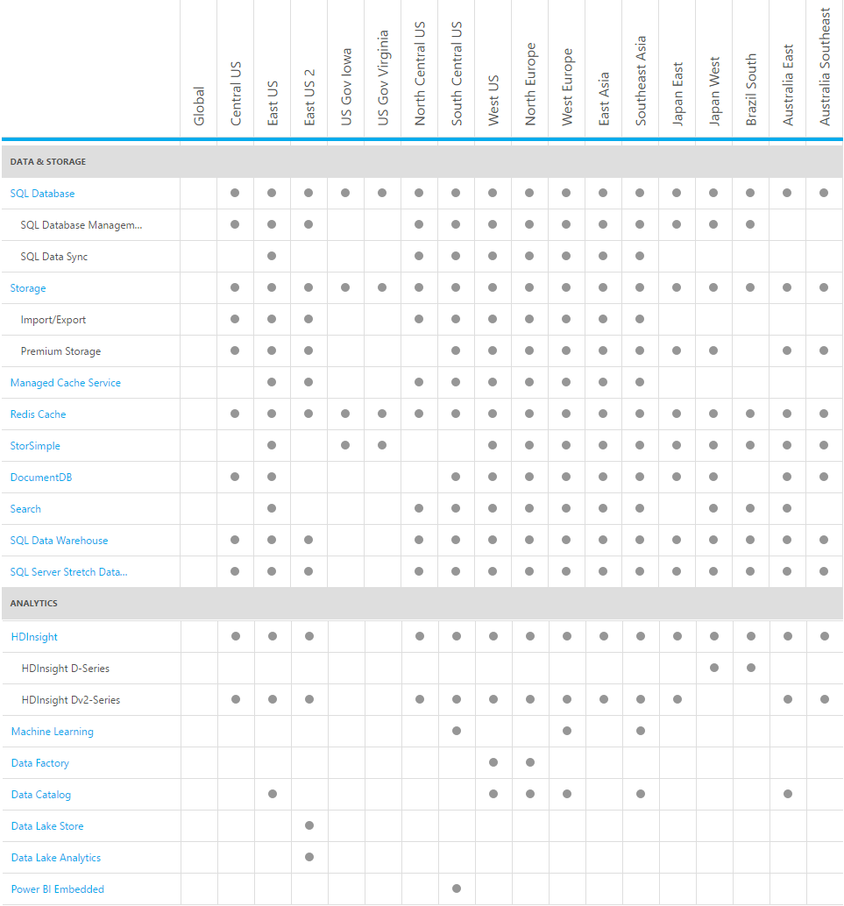
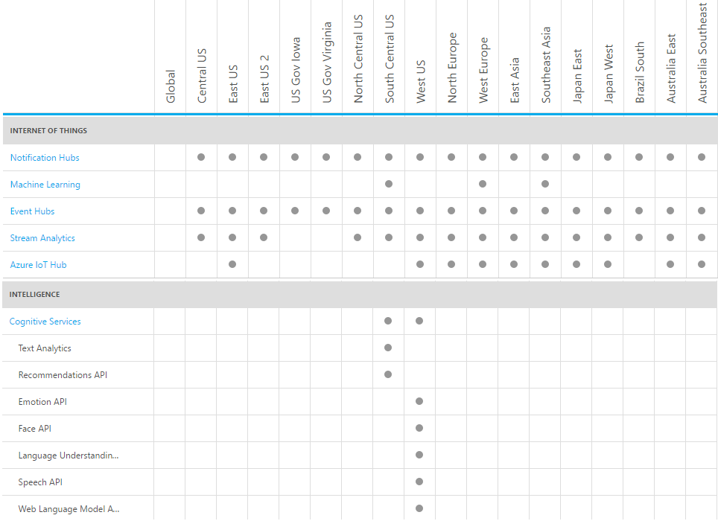

With R Services in SQL Server 2016

